**UNIT 9: light**

1. **Draw a rainbow and color it?**

|  |
| --- |
|  |

1. **Why do animals need light and heat?**

**______________________________________________________**

**______________________________________________________**

**______________________________________________________**

1. 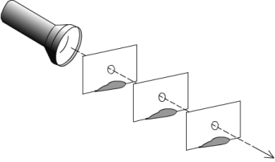**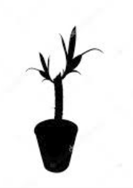Fill in blanks**
2. **Light travels in straight………….**
3. **What object does the shadow belong to?**

**__________________________________**

1. **Decide whether the statements below are true or false..**

|  |  |  |
| --- | --- | --- |
| Statements | True | False |
| 1. The Sun gives off heat and light. |  |  |
| 1. The bouncing-off of light from shiny object is called reflection |  |  |
| 1. Most of things give off light. |  |  |
| 1. Light travels very slowly. |  |  |
| 1. A Shadow can be made without light. |  |  |
| 1. When the sun is high in the sky, your shadow is short. |  |  |