**UNIT 7: Magnets and Magnetism**

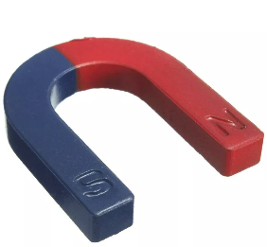

1. **Write the names of the magnets.**

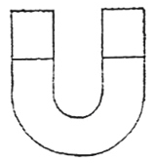**………………..**

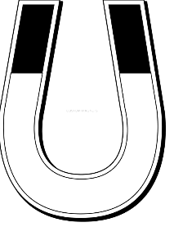**…………………..**

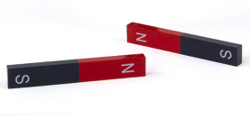**………………………..**

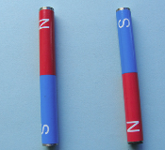 **……………………….**

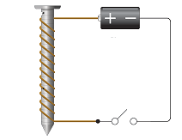 **……………………………**

1. **Fill in blanks**
2. A natural magnet looks like a dark colored rock, it is called……….. or ……………..
3. Artificial magnets are made of ……………….
4. ……………….. magnets are the most powerful
5. Alnico magnets are made of …………., …………and ………
6. The force which holds objects to a magnet is called………….
7. Magnet ends are called………..
8. Opposite poles of a magnet will…………..each other.
9. Magnets are used in many electrical machines, they are used in …………….and ………………..