**Everyday Science Grade (2) Summary:**

**Unit One: (living Things)**

1. All living things can **grow**.
2. All living things eat **food**, some animals eat only plants, some animals eat other animals, and some animals eat both plants and animals.
3. All living things need **air** to breathe.
4. All living things can **move**.
5. Living things have babies which grow big and look like their parents.
6. A Plant has flowers which make seeds which grow to make new plants.

**Unit Two: (Kinds of Animals)**

1. There are many kinds of animals, they have different outer coverings, for example, fish is covered with scales
2. Animals are of many **sizes**, some animals are very big like elephant, and some animals are very **small** like ladybird.
3. Some animals live in very **cold** places, other live in very **hot** places.
4. Some animals live both in water and land like crocodile.

**Unit Three: (Kinds of Plants)**

1. **Parts of a plant:**

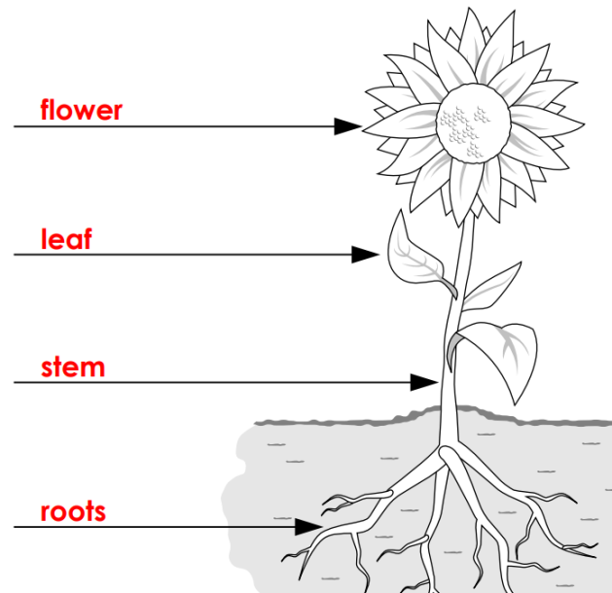

**Roots**: grow in the soil; they suck water and salts from the soil.

**Stem**: takes water and salts from the roots.

**Green Leaves** make food from the plant.

**Flowers** make fruits which have seeds inside them.

Green plants need air, water and sunlight to make **food**.

1. Some plants grow very tall, they are called **trees**, and they have hard, woody stems.
2. Some plants do not grow very tall, they are called **shrubs**.
3. Some plants grow close to the ground, they are called **herbs**.

**Unit 4: Roots**

1. Roots grow in the **soil**, it sucks water and salts from the soil.
2. Roots store food for the plant.
3. It fixes the plant in the soil.

**Kinds of Roots:**

* Some roots have one big part which is thick; this thick root is called a **tap-root**.
* Some roots have many branches of the same size; these roots are called **fibrous roots**.

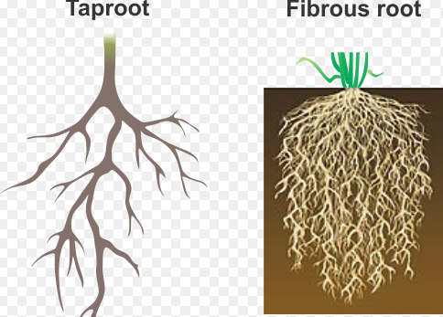

**Unit five: (Leaves)**

* The green color of the leaf is due to the colored substance called **chlorophyll**.

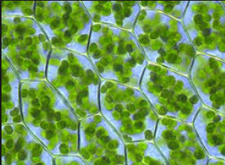

* Leaves of many shapes and sizes.
* A leaf is joined to the stem by a leaf stalk.
* When one leaf grows on a leaf stalk, the leaf is called **simple leaf**, when two or more small leaves grow on a leaf stalk, the leaf is called a **compound leaf**.

Simple Leaf 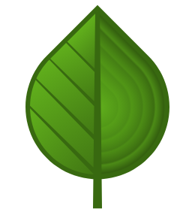 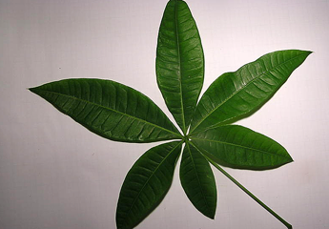 Compound Leaf

* Green leaves make food for the plant, the food of the plant is glucose.
* A leaf makes food with the help of air, water, chlorophyll and sunlight.

**Unit (Six): Fruits and seeds:**

* A fruit is made from a **flower**.
* Seeds are made inside **fruits**.
* Seeds are dry and small, some seeds are very small and some are very big.
* A seed has a hard **seed coat**, which protects the seed.

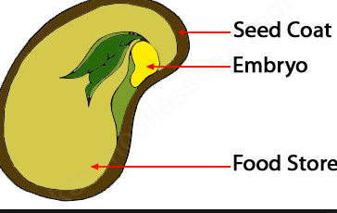

**Unit Seven:**

**(Work and Machines):**

* Some things move fast, other move slowly.
* We can move things by **pushing** or **pulling** them.
* We do **work** when we push or pull something.
* A push or pull is called **force.**

**(Machines):**

* Machines help us to do many things, some are big, and some are small.
* Big machines need **fuel**.
* Fuel gives energy to the machine to do **work**.

**Unit Eight (Light):**

* All the light on the earth comes from the sun.
* When something gives out light by itself, it is called a **Luminous.**
* Thing which cannot give out light by itself is called a **non-luminous thing.**
* Things that let light pass through clearly are called **Transparent.**
* Things that let light pass through but not clearly are called **Translucent.**
* A beam of light travels in a straight line.
* If something comes in the path of light, it makes a dark patch. This dark patch is called a **shadow**.

**Unit nine (Heat):**

* Fire gives us heat; heat is a kind of energy.
* Heat energy comes from burning wood, paper and other flues.
* Animals have hair or fur on their bodies to keep them warm.
* Metals through which heat can pass are called **Good Conductors**.
* Heat cannot pass are called **Bad Conductors**.

**Unit Ten: (The Sun and Stars):**

* Stars shine at night, they are very big, but they look small because they are very far away.
* Sun gives us heat and light, sunlight helps our skin to make vitamin D.
* The light of the sun helps to make wind and rain.

**Unit 11: The Moon**

* The Moon is 400 000 Km away from the Earth, it moves around the earth.
* We can see the moon best at night, sometimes it looks round like a ball, and this is called **full moon**.
* Sometimes we see only half of the moon, it is called **half moon**.

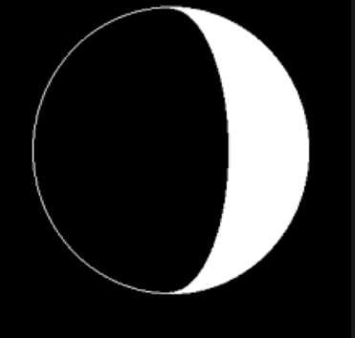

Half Moon

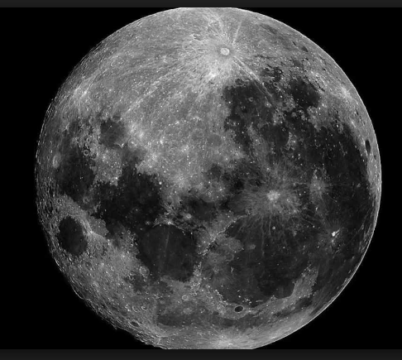

Full Moon

**Unit 12: The Earth**

* There is a layer of air around the earth**.**

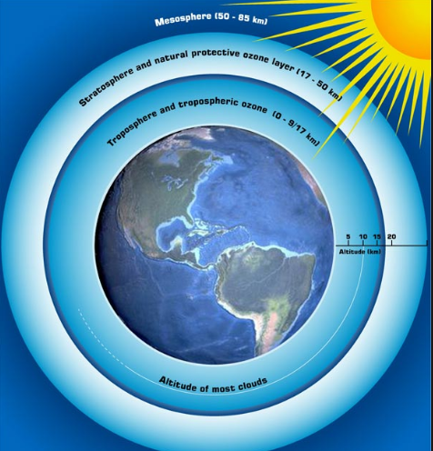

* There are many oceans, **seas**, **lakes** and **rivers.**
* The earth turns round once in 24 hours**.** The turningof the earth on its axis makes **day** and **night**.
* There are four directions**: north, south, east, and west.**

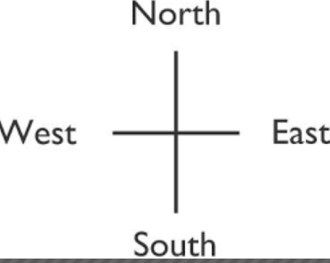

* There are four seasons in one year; they are called **winter, spring, summer, and autumn.**

