**Unit 3: Kinds of plants**

1. **Label the following Diagram.**

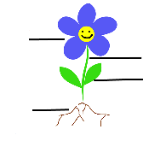

1. **Write the names of the following plants.**

**……………………………….**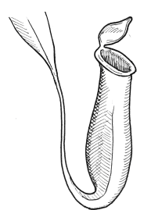

**b)**

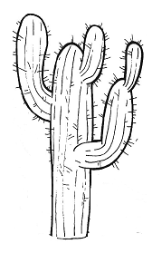**……………………….**

**3) Writ Yes or No.**

a) Plants that grow very tall are called mosses…….

b) Herbs have hard, woody stems…………..

c) Trees grow very tall………………………