**Every Day Science 4:**

**Unit One:**

Growth and Movement in Living Things: Living things are quite different from non-living things. They have characteristics which non-living things do not have.

**What living things can do?**

* **Movements in animals:** Animals can move parts of their bodies. They can also move from one place to another. Animals have special body parts that help them to move.
* **Growth in animals:**

Animals are living things. They eat food to grow big. The whole body of animals grows. It keeps on growing till it becomes as big as

Its parents.

* **Growth in plant:** Plants keep on growing all their lives. If you cut off the tip of a stem, new branches will grow from the sides.
* **Uses of Animals:**

Cattle and sheep give us meat, milk, wool and hide. Milk can be made into

Butter, yoghurt and cheese.

* **Uses of Plants :**

Crops provide us with food grains. Cotton and jute plants give us fiber for

Making cloth, Trees are useful for building houses and furniture.

**Population and food needs:**

As the population of the world is increasing, the need for food is also increasing; Better ways of growing crops and better fertilizers will lead to

An increase in the production of food.

**Unit Two:**

**A Balanced Diet:**

Food gives energy to the body. It also helps the body to grow; Food contains many different substances that keep the body fit and healthy.

**Carbohydrates and fats** give energy to the body. Carbohydrates are found

in potatoes, rice and bread, Fats are found in milk, butter and cheese**.**

**Proteins** help the body to grow and repair worn out or damaged parts.

These are found in meat, eggs, milk and grains.

**Vitamins and minerals** in food keep the body healthy.

**Food and Health:** To stay healthy, you must eat meals that contain all the food substances

in the right amounts. Eating such food is called a **Balanced diet.**

**Unit Three:**

**Living Things and their Environment:** Every living thing is linked to every other living thing in the world. Living things are also linked to the non-living things in the world, such as sunlight, soil, water and air. Living and non-living things

**What animals eat?** Some animals eat plants. These animals are called herbivores. Sheep, cows and rabbits are **herbivores**.

Some animals eat other animals meat they are called carnivores. Lions, tiger, Foxes and dogs are **carnivores**.

Human being and some animals eat both plants and animals. They called **omnivores**.

**Food Chain:**

Food energy passes from plants to animals in the form of a long chain

This is called a **Food chain.**

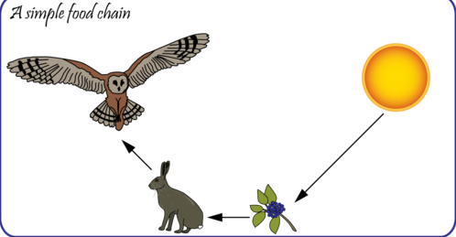

**Food cycle:**

When plants and animals die, all the chemical substances in their bodies return to the soil.

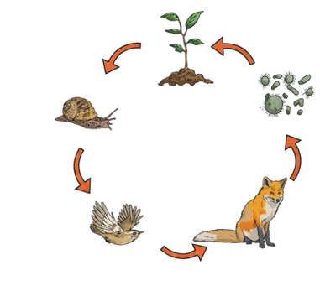.

* **Food Web**:

One kind of food is eaten by many animals, and many animals eat the

Same kind of food. Food chains cannot be separated from each other.

They are linked to each other at many points. These linked food chains

make a food web.

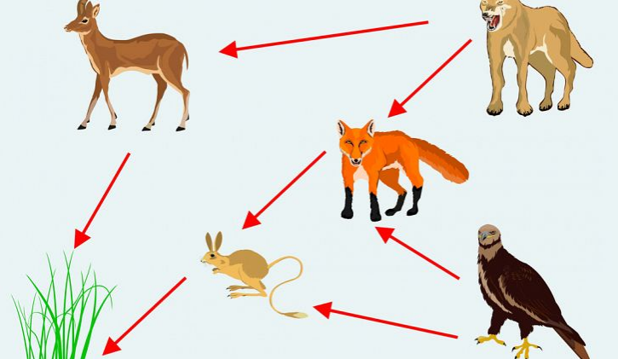

* **Adaptations :** Process by which an animal or plant becomes fitted to its environment**.**
* **Adaptations in Animals:**

Each animal is fitted or adapted to live in its surroundings or environment. It is adapted to find food. It is safe from heat and cold.

It is safe from its enemies.

Some animals have special body parts for protection.

* **Animals that live in very cold places:**

Animals that live in very cold places, like polar bears, seals and whales, have thick fur on their bodies. They have a thick layer of fat under their skins.

* **Animals that live in very hot places:**

Most animals that live in very hot places, like camels and snakes

rest during the day and look for food at night. They can store water in their bodies for a long a time.

* **Plants are fitted to live in their surroundings:**

Plants that grow in very cold places have needle-like leaves.

They make seeds inside cones.

Plants that grow in very hot places have thick, fleshy stems which can store water.

**Unit four:**

* **Mixtures**

A combination of two or more substances that keep their properties.

Coffee is a mixture of water, sugar and coffee beans.

* **Kind of mixture** :

When we mix sugar and water, the **mixture** is clear. We cannot see sugar in the water. This mixture is called a **solution**.

We cannot see the sugar because it has mixed with the water. The sugar has dissolved in it. In a solution of sugar and water, the sugar is called the solute and water is called the **solvent**.

Some substances are not **soluble** in water. We say that they are insoluble. They do not dissolve in water.

* **Separating mixtures:**

**By filtering:** Filtering is done to separate a solid from a liquid.

**By evaporating**: Salt can be separated from water by **heating** the solution and

The salt will be left behind. The water will evaporate from the solution.

**By stirring with a magnet:** A mixture of sand and iron filings can be separated by stirring the mixture with a magnet. The iron filings will stick to the magnet and the sand will be left behind.

**Unit Five: Water**

* **States of Water:**

**Water is found in three states or forms**

Solid water is **ice.**

Water in liquid form is **water.**

Water in gaseous form is **water vapor.**

* **Water Cycle**

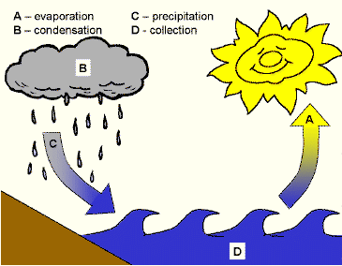

Water can easily change from one form to another when the Sun warms the water of seas, rivers, ponds and lakes; it changes into water vapor (**Evaporation**).

Water vapor rises in the air. It cools and changes back into tiny droplets of water which form clouds (**Condensation**). The drops then fall to the ground as rain (**Precipitation**).

In cold weather, the water drops in the cloud freeze and fall as hail or snow.

**Unit six:**

The Earth is surrounded by a layer of air.

Air is a mixture of gases. It consists nitrogen, oxygen and a little carbon dioxide, dust and water vapor. It also has small amounts of other gases like argon and helium.

* **Breathing :**

Living things breathe all the time. They need oxygen to produce energy.

Glucose from food combines with the oxygen that they breathe in from

the air.

* **Air pollution :**

Fresh air contains oxygen which is needed by all living things.

The air in towns and cities contains many substances that can harm living

things. Burning coal and oil produces harmful gases such as sulpher dioxide.

**Unit seven:**

**Magnets and Magnetism:** An object that can attract iron is called a magnet.

**Shapes of Magnates:**

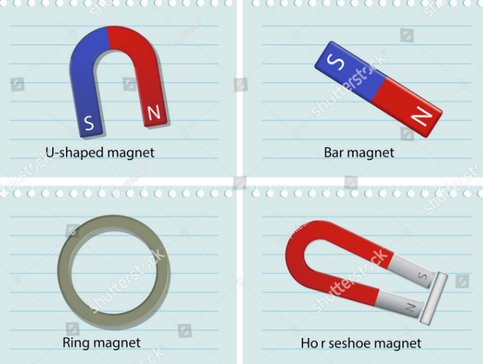

* **Electromagnets :**

Electromagnets consist of a coil of wire wound round a rod of iron.

When an electric current is passed through the coil, the iron rod becomes a magnet.

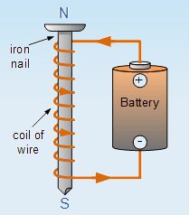

* **Force of a magnet :**

You can pick up steel pins and paper clips with a magnet. You have to pull hard to pull the pins from a magnet.

The force which holds objects to a magnet is called **Magnetic Force**.

Wood, rubber and paper **are non-magnetic materials.** Magnetic force can act through non-magnetic materials.

* **Poles of Magnet:** The part of a magnet where the ability to push or pull is the strongest.
* **Attraction and repulsion :**

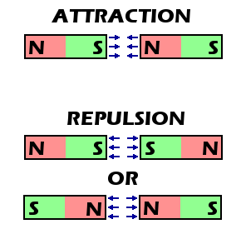

Bring the **North Pole) N**) towards the North Pole of magnet, and

it will swing away from it. Put another magnet near its **South Pole (S)**. The opposite poles will rush towards each other.

**Unit 8:** **Static Electricity**

Each of these tiny particles can have an **electrical charge**. There are two kinds of electrical charge, **positive** or **negative**, that can:

• Repel (push away) each other—if they are the same kind of charge.

• Attract (pull toward) each other, if they are opposite charges.

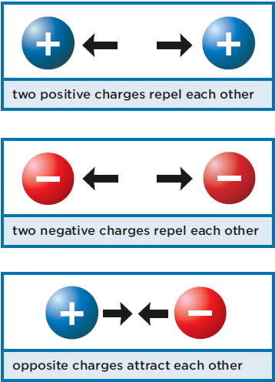

Most objects are made up of the same number of positive and negative charges. Objects with the same number of both charges are **neutral**.

When two objects touch or nearly touch, charged particles can move from one object to the other.

**Negative** charges move from object to object more easily than **positive**

Charges.

For example, rub a balloon with a wool cloth:

• Negative charges move from the wool to the balloon

• The balloon now has more negative charges than positive charges. The balloon is negatively charged.

**Unit Nine 9: Heat**

When molecules move fast they produce **heat**.

**Thermometers:**

A thermometer to find out exactly how hot something is**.**

**Celsius scale**: In the Celsius scale, the freezing point of water is 0 C

C and the boiling point of water is 100 C.

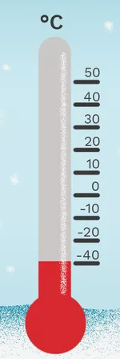

**Unit 10: Heat**

The **Sun** gives heat and light to the Earth.

We can see objects because they scatter light in our eyes. A burning candle

and a bulb give out light.

Light carries energy.

Light travels very fast.

Light can travel through space.

Light travels in straight lines.

**Reflection of light:** When a ray of light falls on a smooth surface such as a flat mirror, it bounces back in the opposite direction.

The bouncing back of light is called the reflection of light.

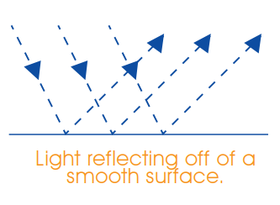

**How do we see things?**  Things such as the Sun and candles give off light. They are called **luminous bodies.**

Light from the Sun, a lamp or some other luminous body shines on them. It is only then that we can see them.

Bodies which do not give off their own light are called **non-luminous** bodies.

**Unit 11: Movement of the Earth:**

The Earth is always spinning. It goes round its axis through the North and South Poles. It takes 24 hours to spin once on its axis.

* **Day and Night:**

As the Earth spins on its axis, the part of the Earth which faces the Sun has

Day time. The part of the Earth which is on the other side has night.

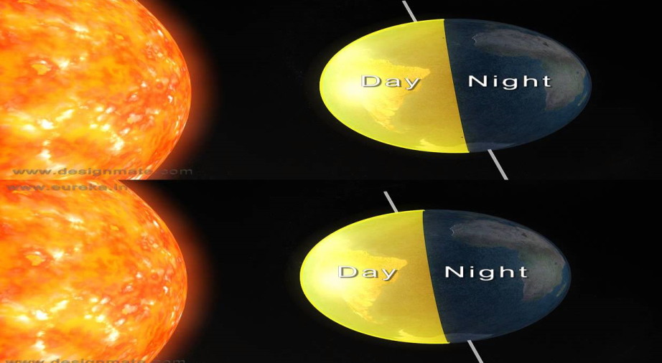

* **Seasons:**

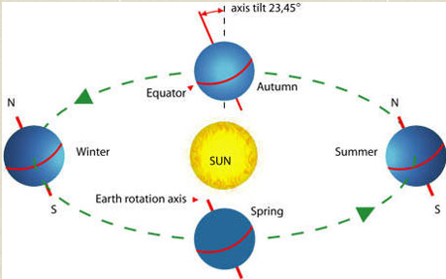

The axis of the Earth is not straight up or down. It is slightly tilted. The Earth goes round the Sun in one year or **365 days**.

During the year, sometimes the North Pole is tilted towards the Sun, and Sometimes the South Pole is tilted towards it. The part of the Earth which is tilted towards the Sun gets lighter, so it is warmer. It has **Summer**. The part which is tilted away from the Sun gets less light, so it is colder. It has **Winter**.

When the Earth is not tilted away from or towards the Sun, it gets equal amounts of light, and it is either **Spring** or **Autumn.**