**UNITS 12+13 : The Earth**/ **The Seasons**

1. **Name the four Directions**.

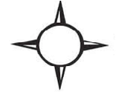

1. **Write Yes or No**.
2. The Earth gets heat and light from the Moon…..
3. Three-fourths of the Earth is covered with water……
4. There are five directions………….
5. The Earth turns round twice in 24 hours……..
6. We can see the Sun at night……………
7. The turning of Earth on its axis makes the four Seasons…….
8. The side which has day becomes cold…………
9. People wear woolen clothes in summer………
10. It snows in spring ………..
11. Leaves fall off the trees in autumn……