**UNIT 5: Air**

1. **Look at the picture below. Complete the contents of the Earth’s atmosphere.**

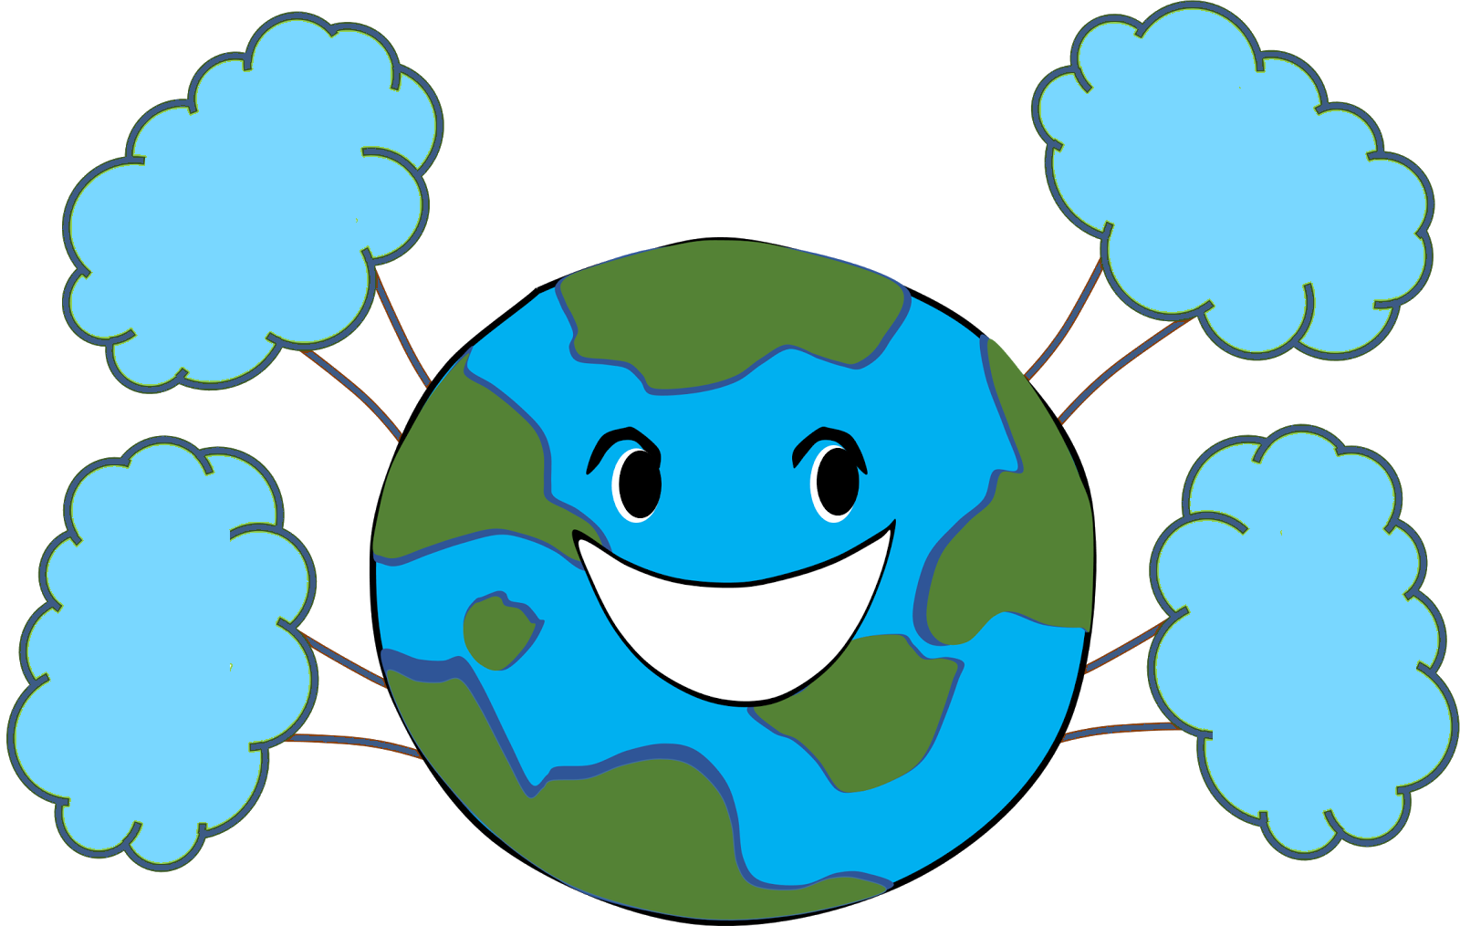

1. **Complete the table below.**

|  |  |  |
| --- | --- | --- |
|  | **Oxygen** | **Carbon Dioxide** |
| **is used by** | 1. **________________** 2. **________________** | 1. **________________** |
| **is given out when** | 1. **________________** | 1. **________________** 2. **________________** |

1. **Read the statements below. Complete each statement with the suitable word or phrase.**

**air pressure– breeze – gale – hurricane**

1. The way air presses down on all things is called _______________.
2. A light wind is called ______________.
3. Strong wind is called_______________.
4. The strongest wind of all is called a __________________.
5. **Look at the pictures. Answer the questions.**



1. **What are the kids making?**

**They are making ______________.**

1. **Why do we use this instrument?**

**We use it to __________________**

**____________________________.**

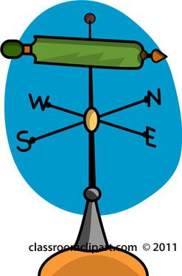

1. **What is this instrument?**

**It is a _______________________.**

1. **Why do we use this instrument?**

**We use it to __________________**

**____________________________.**

1. 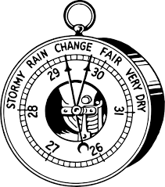**Is this a compass?**

**□ Yes, it is.**

**□ No, it is not.**

1. **What is this instrument called?**

**It is called a _________________.**

1. **Why do we use this instrument?**

**We use it to __________________**

**____________________________.**

1. **Read the statements below and decide whether they are true or false**.

|  |  |  |
| --- | --- | --- |
| **Statement** | **True** | **False** |
| 1. The layer of air around earth called hemisphere. |  |  |
| 1. All living things breathe **out** oxygen. |  |  |
| 1. We can’t measure the speed of the wind. |  |  |
| 1. A light wind is called hurricane. |  |  |