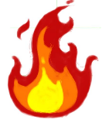**Unit 5: Heat and Light**

**1) Write Yes or No**.

1. We cannot see in the dark____________________
2. Earth gives light to moon____________________
3. A Sunlight is made up of five colors____________________
4. Fire gives us heat ____________________
5. Light can pass through wood____________________

**2) Draw the Sun:**

|  |
| --- |
|  |

**4) Write the names of the seven colors of the rainbow**

a) V__ol__t b) I___dig c)bl__.e d)gr__en

e)Y__ll__w f)Or__ng__ g)r__d.

**5)** **Fill in blanks**

a) A candle gives out___________________ and __________________

b) Light help us to see in the____________________.

c) We need heat to keep us ________________ in _________________

d) We need ____________________to cook our food.

e) We can see the seven colors of light in a ____________________