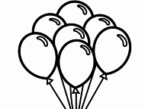**Unit 6: Air**

1. **Write Yes or No.**
2. We can see air_______________
3. Air is around us _______________
4. When the air is cold, we feel hot_______________
5. Drops of water in air make clouds_______________

**2) Draw things that we fill air with. Write their names**

|  |  |
| --- | --- |
| ____________________________ | **__________________________** |

**3) Fill in blanks.**

a) We cannot see air but we can _______________it.

b) All living thing need _______________

c) _______________fly in the air.

d) Strong wind is called a ______________

**4) Draw on thing that can fly in the air.**

|  |
| --- |
|  |