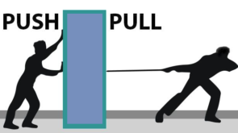**UNIT 7: Force**

1. **Name the kind of energy that is used in**
2. a washing machine _______________
3. a torch_______________
4. a steam engine _______________.
5. a plant to make food _______________
6. **Read the statements below. Decide whether they are true or false.**

|  |  |  |
| --- | --- | --- |
| Statements | True | False |
| 1. Work is done when push or pull makes something move. |  |  |
| 1. Solar energy comes from burning things. |  |  |
| 1. Heat energy comes from the Sun. |  |  |
| 1. The force of gravity pulls everything towards it. |  |  |
| 1. Friction force can be harmful. |  |  |
| 1. Pushes and pulls are called force. |  |  |
| 1. The force which slows down or stops a moving thing is called gravity. |  |  |

1. Draw three things which need electricity to work.

|  |  |  |
| --- | --- | --- |
|  |  |  |