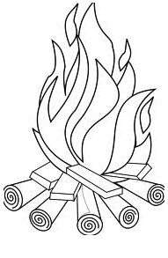**UNIT 8: Heat**

1. **Fill in blanks with the correct answer.**
2. Fire gives us _______________
3. Anything which can do work has_______________
4. Cold water has _______________heat than boiling water.
5. To find out how hot something we use an instrument called_______________
6. Thermometer has bulb filled with liquid called_______________
7. **Read the statements below. Decide whether they are true or false.**

|  |  |  |
| --- | --- | --- |
| Statements | True | False |
| 1. The heat energy which keeps our bodies warm comes from food. |  |  |
| 1. All things have heat. |  |  |
| 1. Molecules move because they have energy. |  |  |
| 1. We can feel the energy of the molecules as heat. |  |  |
| 1. Heat cannot change the state of things. |  |  |
| 1. The heat of the atmosphere does not change daytime and night time temperature. |  |  |