Food Webs and Food Chains Worksheet

**1** Look at this food chain.



lettuce greenfly ladybird thrush cat

**a** What does the arrow mean in a food chain?  **b** Name the producer in the food chain  **c** Name the third trophic level in the food chain.  **d** Name the tertiary consumer in the food chain.

**e** What is the ultimate source of energy that drives the food chain?

1. Look at these food chains.



grass → slug → thrush → cat



grass → slug → fox

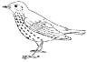

fox

thrush

cat



grass → rabbit → fox

* 1. Use the food chains to help you fill in the arrows on this food web. One has been added for you.



grass → rabbit → cat

slug

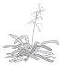

grass

rabbit

Use the food web to help you answer these questions.

* 1. Name the producer in this food web.  **c** Name a consumer in this food web.  **d** What eats rabbits?  **e** What does a fox eat?

**3** Look at this food web. Then answer the questions.

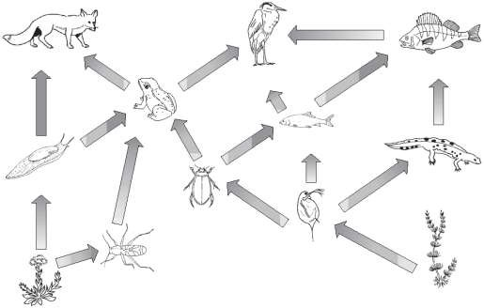fox perch

heron

slug

land plants

frog

insect

diving beetle

small fish

water fleas

newt

tiny water plants

1. Name two producers in the food web.
2. Name three consumers in the food web.
3. Write a food chain from this food web with six trophic levels.
4. Name the animals that the small fish eats.
5. Name the animals that eat the small fish.
6. Explain what could happen to the community if all the frogs suddenly died.

**4.** How are food webs different to food chains? Explain why food webs are more useful.