**UNIT 7: Simple Machines**

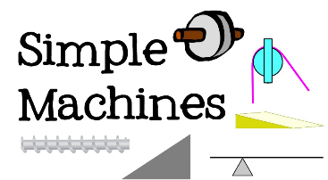

1. **Name some machines that we use at home, in the office, on the road?**
2. **____________________ c. ___________________**
3. **____________________ d. ____________________**
4. **What is wheel and axle?**

______________________________________________________

______________________________________________________

1. **Name the function of the following machines**

|  |  |
| --- | --- |
| Name of the machine | Function |
| Inclined plane |  |
| Wedge |  |
| Screw |  |
| Pulley |  |
| Axle |  |