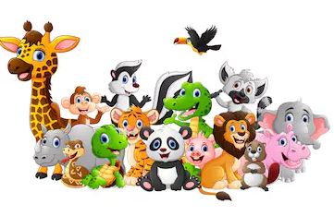 **Unit 2: Animals**

1. **Complete the Table.**

**(Fish, Tiger, crab, Lion)**

|  |  |
| --- | --- |
| Wild Animals | Water animals |
| ______________________________________ | ______________________________________ |

1. **Make pairs of similar animals.**

|  |  |
| --- | --- |
| lion  cow  duck  butterfly  whale | sheep  starfish  tiger  crow  bee |

1. **Read the statements below. Each statement has a mistake. Underline each mistake and correct it**.
2. A cow has feathers.

______________________________________________

1. Most fishes can fly.

______________________________________________

1. A Butterfly gives us milk.

______________________________________________

1. Frogs only live in water.

______________________________________________

**4.** **Complete the names of five wild animals.**

1. T…ger b)....onkey c)…..ion d) F….x.
2. **Write the names of the insects (Bee, Butterfly, Ant, Fly)**

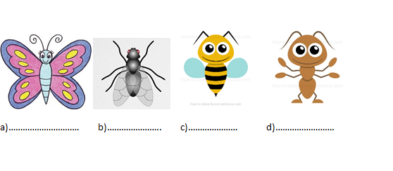

1. **Choose the correct answer:**
2. Animals are_________.
3. living things b)non-living things
4. Insects are________.
5. very large animals b) very small animals
6. A ____________ lives in water.
7. sea horse b)fox
8. **Write Yes or No.**
9. A tiger give us meat ………
10. A parrot has feathers …….
11. A dolphin can run………...
12. A peacock lives in water …….
13. Draw and color ladybug.

|  |
| --- |
|  |