**UNIT 2: A Balanced Diet:**

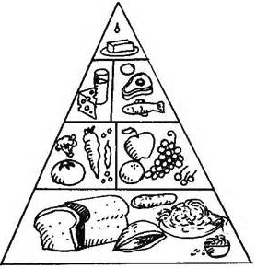

1. **What is balanced diet?**
2. **Name the important food substances?**

**a)**

**b)**

**c)**

**d)**

**f)**

1. **Fill in the Table.**

|  |  |  |
| --- | --- | --- |
| **Type of food** | **Found in** | **Use in the body** |
| Proteins |  |  |
| Fats |  |  |
| Carbohydrates |  |  |
| Vitamins and Minerals |  |  |
| Fiber |  |  |