**Unit 9: Heat**

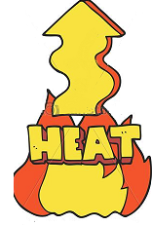

1. **Write Yes or No**

a) Fire gives us heat ………

b) Heat makes us feel cold ………

c) Heat is kind of energy…………

d) Heat energy comes from burning woods…….

e) Metals which heat cannot pass are called good conductors .of heat………..

f) Heat cannot pass through some solids such as wood ………