**Students name:………………………. Date: / /   
Unit 1: Science**   
  
what is science?   
The study of the world using our senses.   
  
**1. True or false**  
   
A. Stone is hard …………  
B. Tea is cold ………...  
C. Rabbit is slow ………….  
D. An elephant is big. ………….  
  
**2. Choose the best answer.**  
  
A. A Horse is (strong / weak)   
B. An ant has (four / six) legs   
C. Tortoise is (fast / slow)   
D. A football is (round / square)   
  
**3. Color this paints.**  
  
 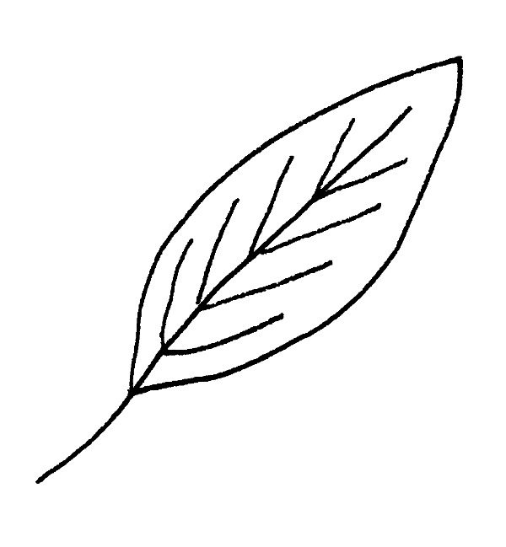  
 (L……F) (F…………R)