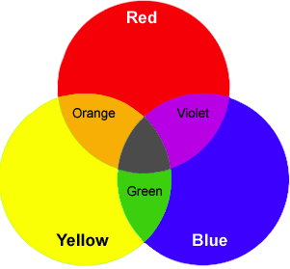**UNIT 8: Light**

1. **Read The statements below. Fill in the blanks with the correct answer.**
2. The bundles of energy are called _________________
3. The sun is a _________________body.
4. The moon is _________________body.
5. The spectrum is _________________
6. Red, blue and green are called _________________colors.
7. If we mix primary colors, we get _________________colors.
8. Materials that allow light to pass through them are called_________________
9. Objects that do not allow any light to pass through them are called_________________
10. **What colors will you get if you mix:**

|  |  |
| --- | --- |
| **Mix** | **Color you get** |
| * Red, blue and green |  |
| * Red and green |  |
| * Red and blue |  |
| * Green and blue |  |