**UNIT 11: The Earths Movements**

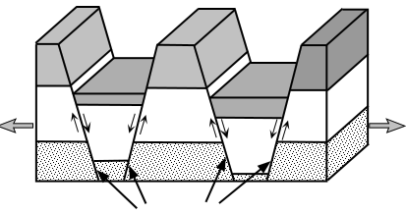

1. What are the types of Earth Movements?
2. _________________________________________________
3. _________________________________________________
4. What is folding? ___________________________________________________

___________________________________________________

___________________________________________________

1. What is a fault? _________________________________________________________________________________________________________________________________________________________
2. What is weathering? _________________________________________________________________________________________________________________________________________________________
3. What is erosion?

_________________________________________________________________________________________________________________________________________________________