**UNIT 11: Movement of the Earth**

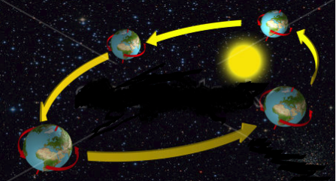

1. **How does the earth spin?**
2. **Why do you see the sun moving from east to west?**
3. **Write the names of the four seasons?**

**a)………………….. b)…………………**

**c)……………………d)…………………**

1. **Which part of the earth has winter?**
2. **What is Constellation?**