**UNIT 4: Roots**

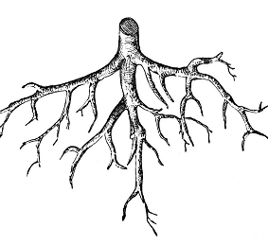

1. **Write YES or NO.**
2. A root stores water for the plant ………
3. Root sucks water and salts from soil…….
4. All roots are thick and strong…………….
5. Tap root has many small roots growing from it …….
6. Tap root stores a lot of food……………….
7. Roots have many branches of the same size are called fibrous roots………….
8. Root cap cannot protect the root tip………..
9. **What are the two types of roots?**
10. 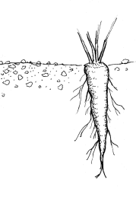 **b)** 