**UNIT 4: MATTER**

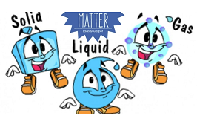

1. **Read the statements below. Decide whether these statements are true or false.**

|  |  |  |
| --- | --- | --- |
| **Statement** | ***True*** | ***False*** |
| 1. The shape of gas changes. |  |  |
| 1. A Gas can flow. |  |  |
| 1. We can see the air. |  |  |
| 1. Matter is made up of molecules. |  |  |
| 1. A liquid can be change into solid by heating. |  |  |

1. Fill in the blanks with the correct words to complete the statements below.

far - water vapor – gas – solid - liquid

1. Heat can change a liquid into _________.
2. When water is changed from liquid to gas, it is called _____________.
3. Molecules in a ________ are very close together.
4. Molecules in a gas are very ________from each other.
5. **Look at the pictures below. Which state of matter do they present?**

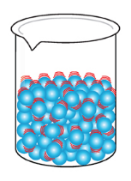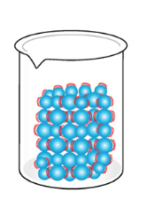

1. _________________ b. ________________

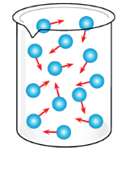

c. _________________

1. **Read the statements below. Choose the correct answer from a, b, or c.**
   1. **Solid can be changed into liquid by ________________.**

a. heating b. cooling c. freezing

* 1. **Liquid can be changed into solid by ________________.**

a. heating b. cooling c. freezing

* 1. **Liquid can be changed into gas by __________________.**

a. heating b. cooling c. freezing

* 1. **Gas can be changed into liquid by ___________________.**

a. heating b. cooling c. freezing

* 1. **Read the statements carefully. Complete the table below using the correct statement.** 
     + Molecules slide over each other.
     + Molecules move freely and bump into each other.
     + Molecules stay in the same place.
     + Molecules push each other away.
     + Molecules can move backwards and forwards.

|  |  |  |
| --- | --- | --- |
| Solid | Liquid | Gas |
| ____________________ | ______________________ |  |