**UNIT 9: Heat**

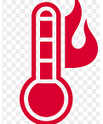

1. **Fill in blanks**
2. All things are made up of tiny particles called…………
3. When Molecules move fast they produce …………..
4. An instrument used to find out exactly how hot something is ……………
5. When the bulb of thermometer is dipped in cold water, the level of the mercury……….
6. The freezing point of water is …………Cℴ.
7. The boiling point of water is ……………Fℴ.
8. The glass tube of a thermometer has ……….in it.
9. **Name the instrument** :

