1. Fill in the blanks using the right words from the bracket.

( straight, beam, refraction, gives, prism, reflection, enters )

Light source is an object that off light. A band of light is called of light.

We can see a light source when the light from the source into our eyes.

Light travels through a path.

Bouncing of light from a shiny surface is called

When light moves from one medium into another it changes its direction which is called of light.

When white light passes through a

it separates into different colors.

1. State whether following materials are transparent, translucent or opaque.

Air Water Cardboard

Frosted glass Wood Wax paper Ceramic Clear glass

1. Shadow of an opaque object is seen in the picture below.

2. Explain how the boy in the picture below can see the ball.

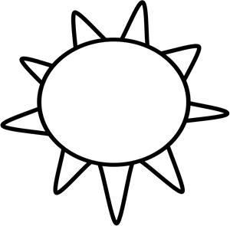Sun

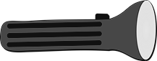



Flash light Opaque object

Screen

Boy

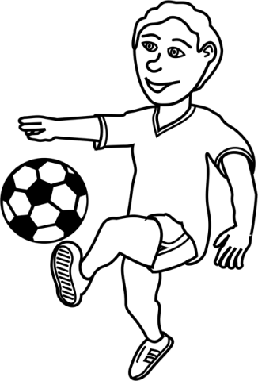

Ball

1. State what will happen to the shadow if the flash light is moved closer to the opaque object.

…………………………………………………………………………………

…………………………………………………………………………………

………………………………………………………………………………….

1. State what will happen to the shadow if the opaque object moved closer to the screen.

…………………………………………………………………………………

…………………………………………………………………………………

…………………………………………………………………………………

…………………………………………………………………………………

1. A signpost
2. State whether following expressions are true or false.