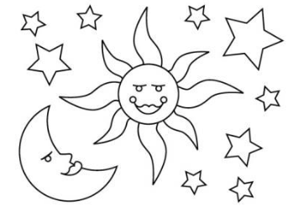**UNIT 7: The Sun and Stars**

1. **Draw the things that we can see in the sky at night**? **Write their names.**

|  |
| --- |
|  |

1. **Choose the right answer:**
2. We can see the sun __________.
3. in the day timeb. at night
4. The sun is a very big ball of ________.
5. hot solids b. hot gases
6. The Earth gets heat and light from________.

a. the sun b. the moon

1. We can see stars______________.
2. in the day time b. at night
3. **Write Yes or No**.
4. Stars are near the Earth_______________
5. Stars are big balls of burning liquids _______________
6. The Moon is also a star_______________
7. The earth gives off light _______________