**Student name: …………………... Date: / /   
Unit 2: Matter**   
  
what is Matter?   
 Matter is a non-living thing, and can be solid, liquid or gas.   
  
**1. Use the proper word below to fill the blanks.**  
 -Solid -Fixed -Liquid -Move   
A. A ………. Is hard  
B. A gas can ……….. from place to place   
C. A ………… can flow  
D. A solid has ……….. shape   
  
**2. Name the state of matter**A) bag _________________ B) juice _________________  
  
C) wood _________________ D) steam _________________  
  
E) rain __________________ F) oxygen ________________  
  
G) hammer ______________ H) air ______________  
  
**3. What is the state of matter in each shape?**  
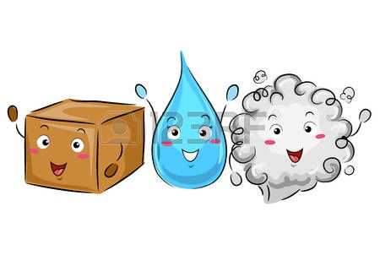   
 (________) (_________) (_________)  
Useful link (https://youtu.be/QQsybALJoew)