Unit 3:Plants
- Label the parts of the plant.
(Flower/ stem /leaf/ root)
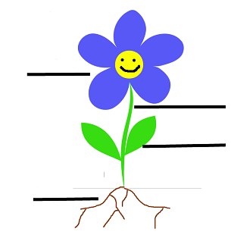

- Draw your favorite fruit.

- Complete the table (Grapes, mango, onion, carrot, apple, peas)
Fruits | Vegetables

- Draw matching lines to join the plant to the place where it grows.

Water lily  Cactus  Pine tree  Pondweed  Date palm | Water  Desert  Cold places

- Fill in blanks.
- Herbs have ________________stems.
- Creepers are ________________plants.
- Trees have ________________stems.
- Plant gives us ________________to make things.

- Write Yes or NO.
1) Green plants can make their own food____________.
2) Green plants don’t need sunlight to make food____________.
3) Almond is a fruit____________.
4) Peanuts are seed____________.

- Draw something from your classroom made of wood.

