**UNIT 1: living Things**

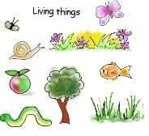

1. **Name the babies of the following animals :**
2. Cat…………………b) Dog…………… c) frog ………….
3. Butterfly ………… e) plant ……………..
4. **Write Yes or No.**
5. All living things have babies which grow big and look like their parents………
6. Living things don’t need air to breathe………..
7. A Fish swims in water with its legs…………..
8. A snake glides on land with its body ……….
9. Plants also move………………………………
10. The stem and leaves of a plant moves towards the ground.
11. **Draw how a seed grows into plant. Label your drawing.**

|  |
| --- |
|  |

1. **Color the pictures** :

