**Student name: …………………... Date: / /   
Unit 2: Animals**   
  
what is animals?   
 Animals are living things, and they have many types and shapes.   
  
Types of animals   
1. Insects 2. Small animals 3. Water animals 4.Wild animals 5. Useful animals 6. Birds   
  
**1. Correct this information**   
   
A. Dolphins live in the ***forest***  …………  
B. Lions live in the ***water***  ………...  
C. Tigers are *small* ***animals***  ………….  
D. Starfish lives in the ***sky***  ………….  
  
**2. Choose the best answer.**  
  
A. butterfly is a kind of (insects / Birds)   
B. An ant has (four / six) legs   
C. Fox is kind of (wild animals / small animals)   
D. A football is (round / square)   
  
**3. Color this paints and answer the questions.**  
 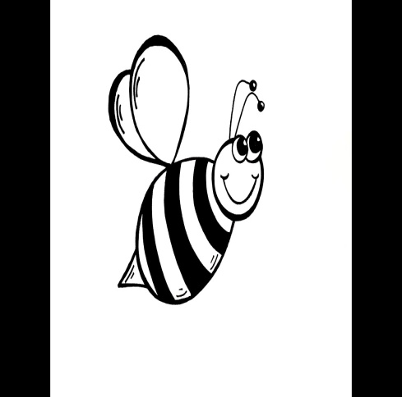 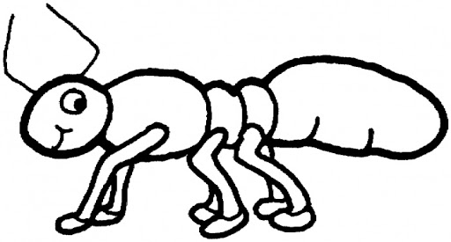  
  
A. How many legs for the ant (…………...)  
B. How many wings for the bee (…………..)  
C. (…………..) are very small animals, they crawl like ants or fly like bees.   
  
Useful link (https://youtu.be/39G0wYrE2Vc)