**UNIT 4: Mixtures and Solutions**

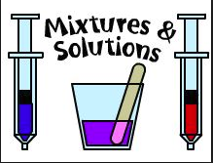

1. **Fill in blanks with the right statements.**
2. In a solution of sugar and water, the sugar is called……..and the water is called …………….
3. Some substances are not soluble in water, we say that they are ……….They do not………..in water.
4. The chalk is insoluble in water, we call this mixture a …………
5. Oil and water do not mix properly, we call this type of mixture an ……………..
6. A mixture of different metals is called an …………..
7. **Name the method of separating the parts of a mixture**.

 