Second Semester
Final Exam

Student’s Name:______________________________
Grade Two
Section: _______________
Teacher’s Name: __________________________
Final Mark: _______ / ______

Question One: Match each of the following with its correct definition:

1.emotional | ( ) a place to live in
2. Islam | ( ) related to the body
3. Medicine | ( ) the religion revealed to prophet Mohammad
4. shelter | ( ) a substance used to treat illnesses.
5. physical | ( ) something related to feelings.

Question two: Decide if the following Sentences are True or False:
1.Arabs before Islam were mostly Bedouins. ( )

2. Kaaba is located in Makka. ( )

3. Bedouins used to send their children to the city. ( )

4. Christians and Jews we not allowed practicing their religion under the Islamic rule. ( )

Question three: Decide if the following habits in each picture are safe or not:

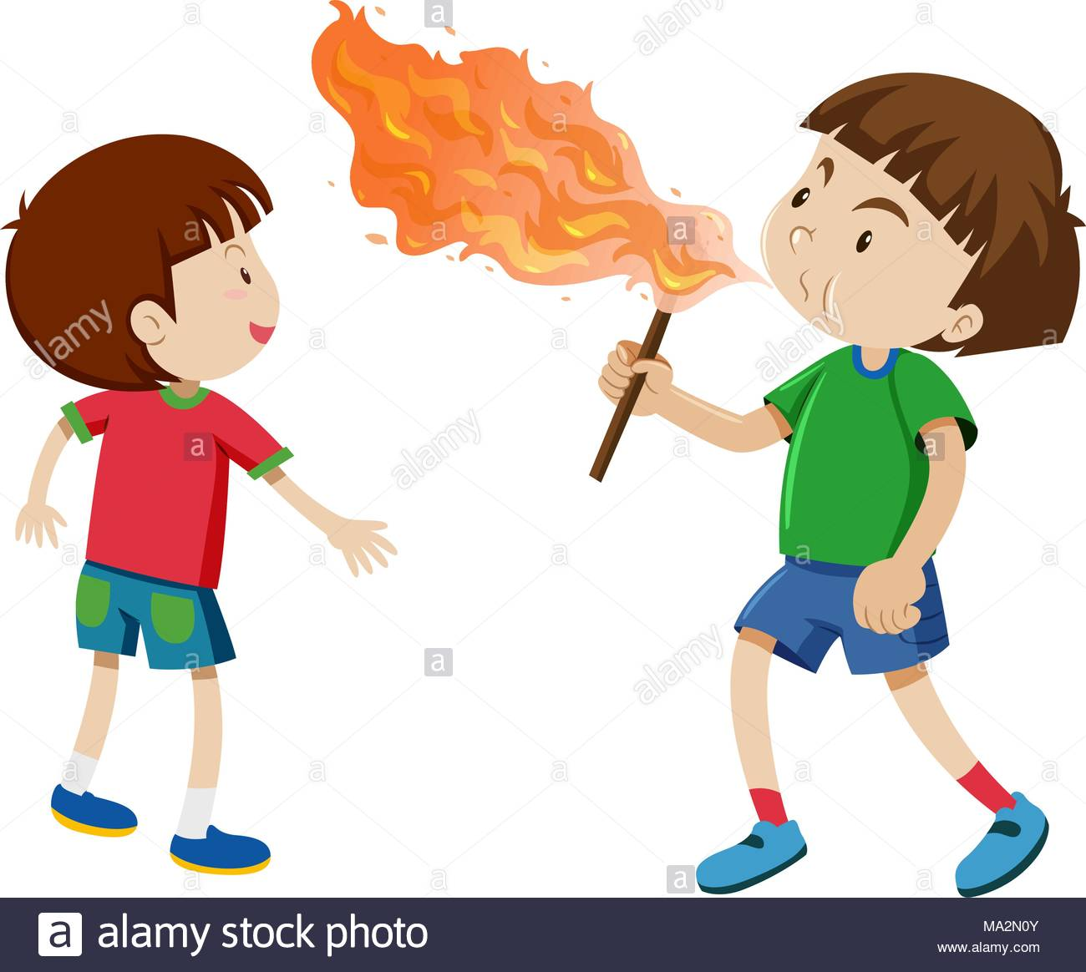
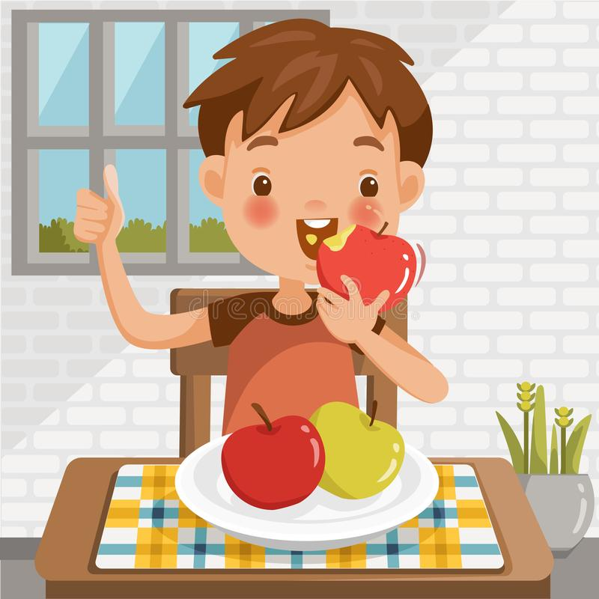
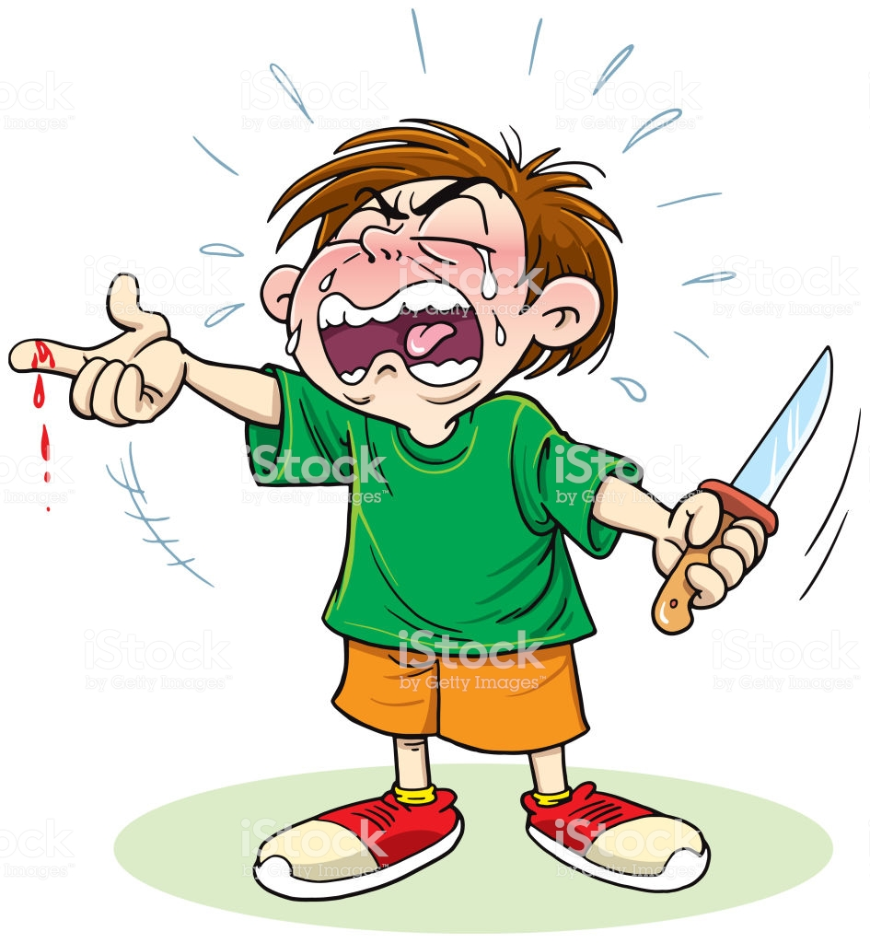

Question Four: Complete the following information about Prophet Mohammad (peace be upon him)
Date and place of birth: _____________________________________________________________________

The year he was born in was called __________________________________________

Mother’s name : _____________________________________________________

Who named him Mohammad? _________________________________________

His tribe is called ________________________ and his clan is _______________________________

His wet-nurse is ____________________________________________

What did people call him ? a. __________________________ b. ________________________

Question five: Complete the following sentences with the name of the correct person:

1. ___________________ is the first woman who believed in Prophet Mohammad.

2. ________________________ is the first lad who believed in Prophet Mohammad.

3. ___________________________ is the name of Prophet Mohammad’s father.

Question six: Classify the following things in the box into needs and wants:
Water chips food ice-cream shelter medicine health care coffee

Needs | Wants

.

Question seven : Choose the correct answer:

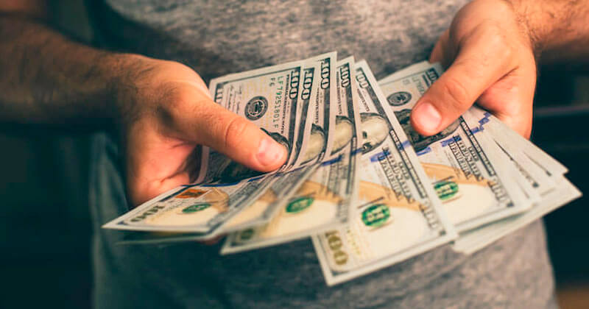

- The money that a country uses is (currency / coin)

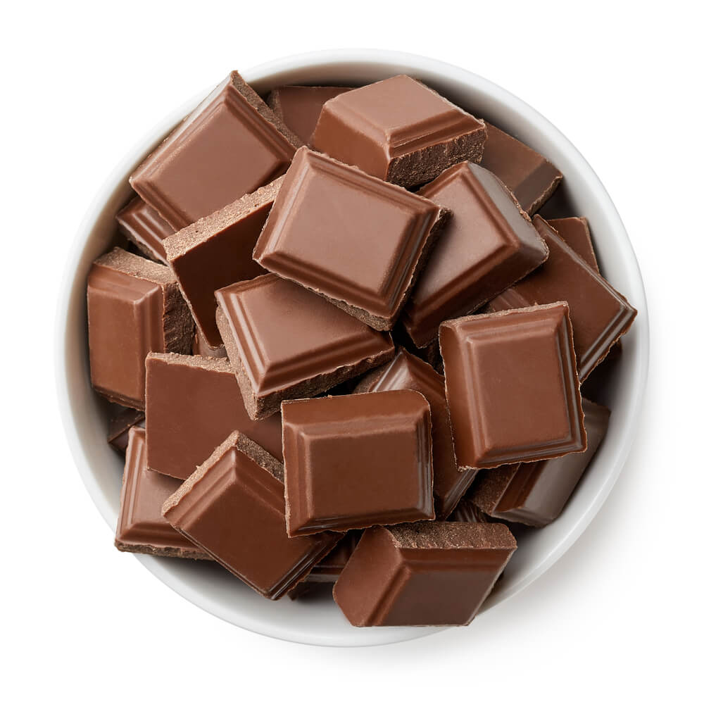

2. ( Chocolate/ medicine) is a need.

1
4
6
2
5
Question eight: Match Each safety rule with the suitable picture:

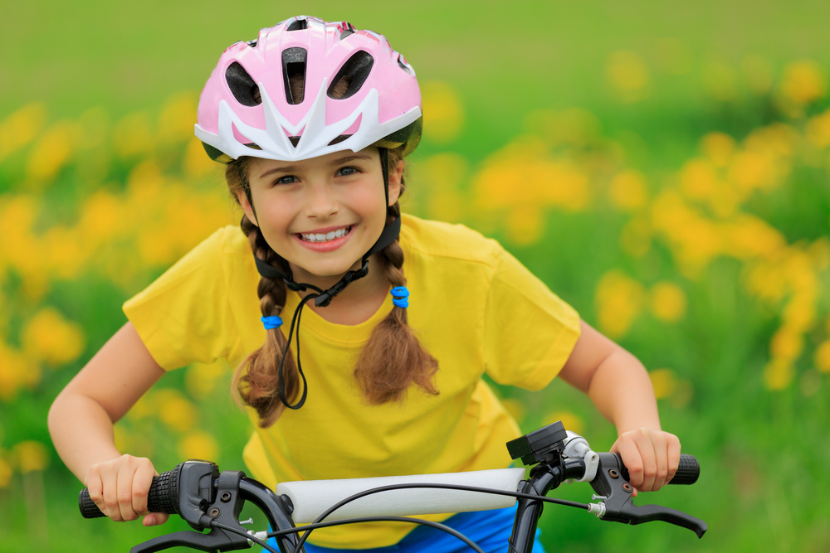 | Use a seat belt
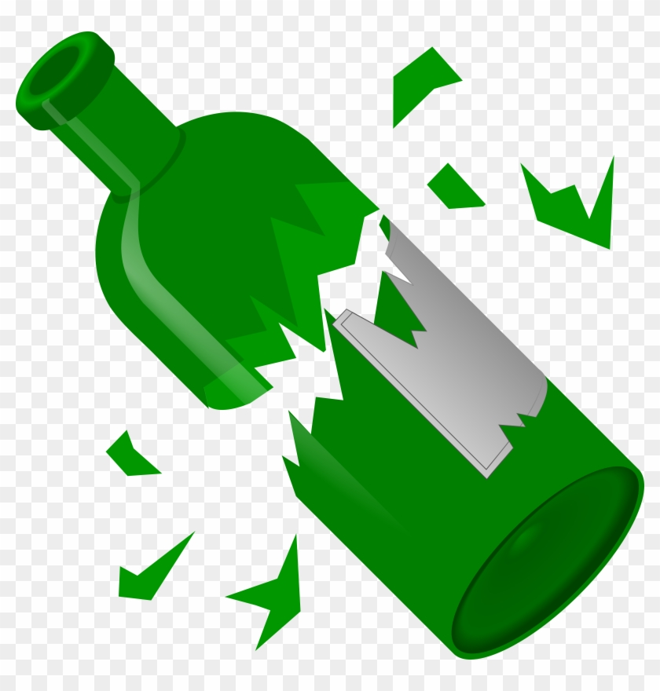 | Avoid cell phones while driving.
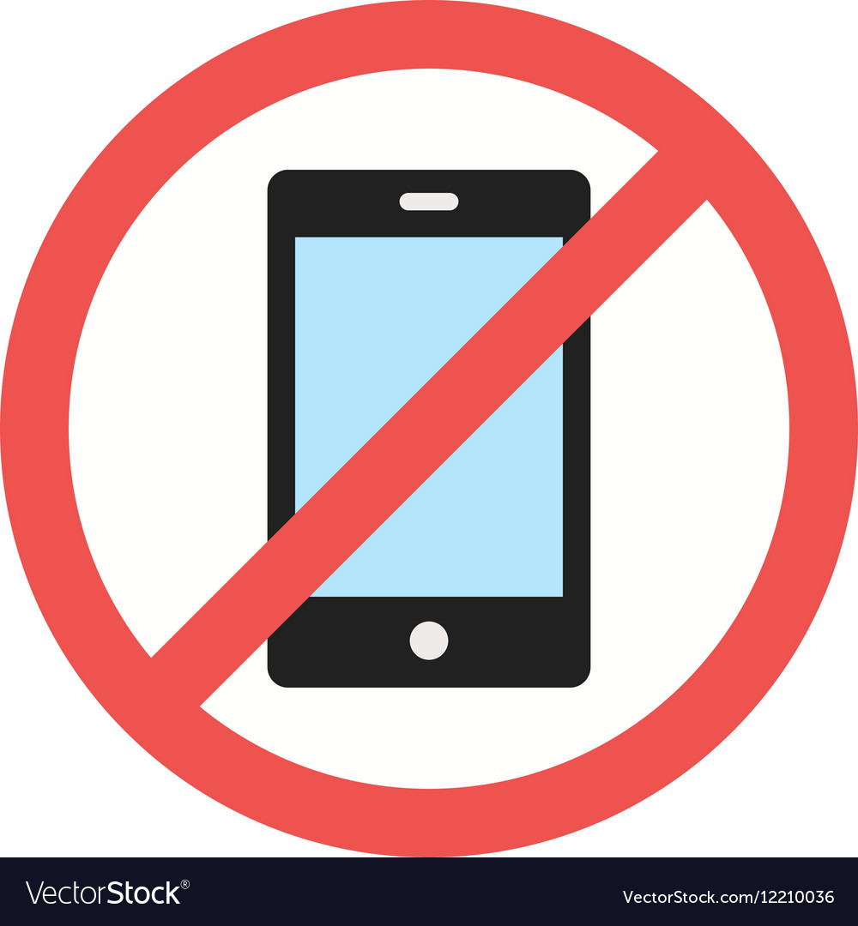 | Avoid broken glasses
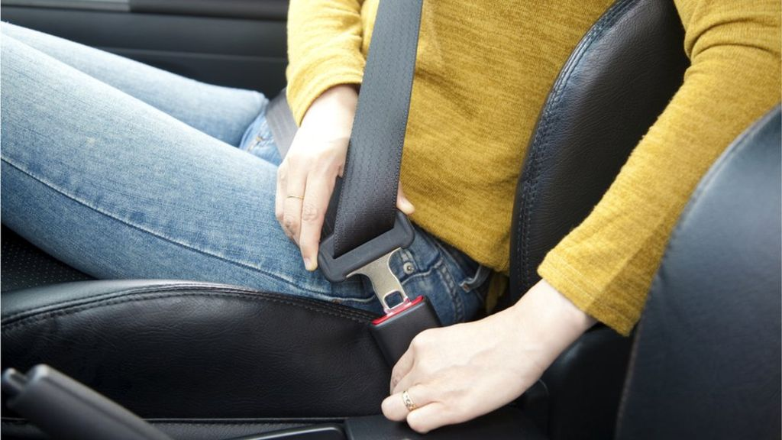 | Use a helmet while riding a bicycle

