Everyday science work sheet  
  
Student name: ____________ Date:__/_/__  
Unite ( 8 ) .

**1. What do magnets stick to?**

Copper

Wood

Iron

Plastic

**2. When two magnets attract, they ______________**

Push apart

Change color

Get colder

Pull together

**3. When two magnets repel, they ________________**

Change color

Pull together

Push apart

Get colder

**4. Magnets have a north and a south ___________**

Shape

Color

Pole

Region

**5. The strongest part of a magnet is...  
  
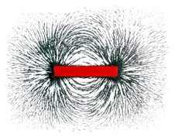**the bars.

The force field.

The poles.

The middle.  
  
**6. Surrounding every magnet is a __________  __________.**

Magnetic field

Electrical current

Another magnet

**7. This is an example of...**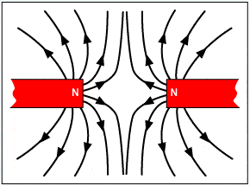

Attraction repulsion