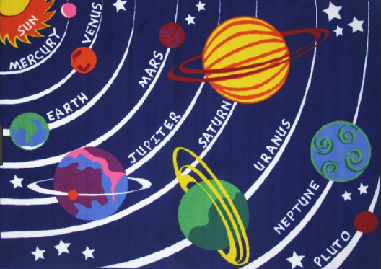**UNIT 11: The Sun and planets**

1. **Fill in blanks**
2. The smallest planet in the solar system is_______________
3. The second planet closest to the Sun is _______________
4. The planet that has air and water is _______________
5. _______________ is called the red planet.
6. The largest planet in the solar system is _______________
7. The planet that takes 29 years to travel once around the sun is

_______________.

1. _______________ is a very cold planet because it is very far away from the sun.
2. _______________ colder than Uranus.
3. _______________ is the farthest planet from the sun.
4. **Arrange the planets in correct order starting from Mercury**

|  |  |
| --- | --- |
| Earth  Mercury  Jupiter  Venus  Uranus  Pluto  Mars  Neptune  Saturn | 1. Mercury |
|  |
|  |
|  |
|  |
|  |
|  |
|  |
|  |

1. **Write the names of the planets.**

