**UNIT 6: Fruits and Seeds**

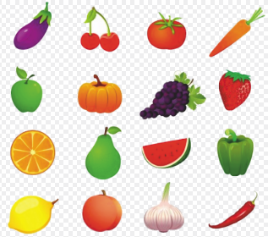

**1.** Write Yes or NO.

a) A fruit is made from root……………

b) Some fruits are soft and Juicy ……….

c) All fruits are dry and hard……………

d) Papaya has few seeds…………

e) Seed has seed leaves and a baby plant inside it**…….**

1. **Fill in the table about the number of seeds in fruits**

|  |  |  |  |
| --- | --- | --- | --- |
| Fruit | One seed | Few seed | Many seeds |
| Apple |  |  |  |
| Papaya |  |  |  |
| Mango |  |  |  |
| Plum |  |  |  |
| Orange |  |  |  |

1. **Label the seed parts:**

