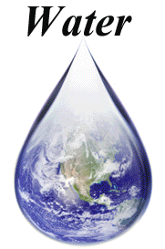**UNIT 6: Water**

1. **label the following diagram (cooling/ heating)**

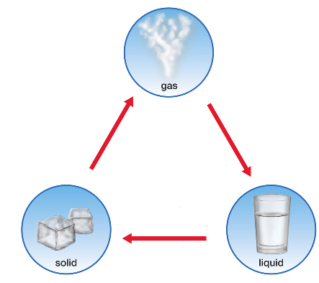

1. **Fill in blanks**
2. The water vapor cools down to form_______________.
3. When Bigger drops of water are too heavy to float in the air, so they fall to the ground as _______________
4. When clouds near the ground on a cold clear night, they form _______________or _______________
5. Each little piece of ice forms a shape called a_______________
6. Fog is _____________________________________________