## Look at the pictures. Can you say the words?

**1 2 3 4**

**5 6 7 8**

**Look at the words. Write the number.**

**a** potatoes ………………………

**b** bread ………………………

**c** coffee ………………………

**d** fish ………………………

**e** apples ………………………

**f** rice ………………………

**g** tea ………………………

**h** tomatoes ………………………

## Write the words again. Look, say, cover, write, check.

|  |  |  |  |  |
| --- | --- | --- | --- | --- |
| **1** tea | ……………………… | **5** | fish | ……………………… |
| **2** coffee | ……………………… | **6** | potatoes | ……………………… |
| **3** bread | ……………………… | **7** | tomatoes | ……………………… |
| **4** rice | ……………………… | **8** | apples | ……………………… |

**Write about you.**

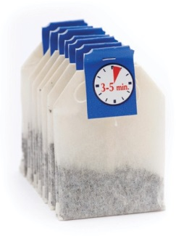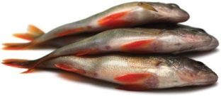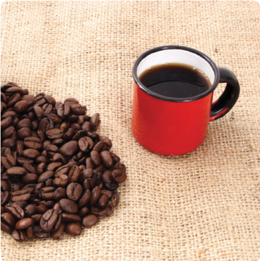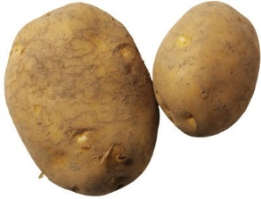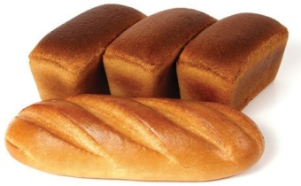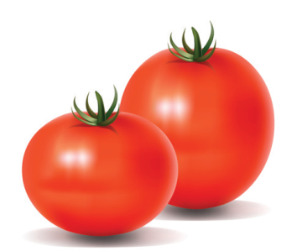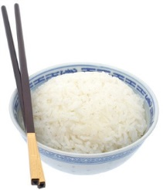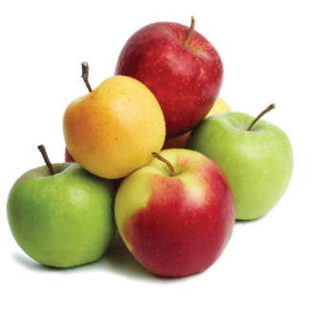

**Look!**

I like tea.

I don’t like apples.

…………………………………………………………………………………………………

…………………………………………………………………………………………………

…………………………………………………………………………………………………

…………………………………………………………………………………………………

…………………………………………………………………………………………………

## Look at the pictures.

**How many words do you know? Tell your partner.**

**1 2 3 4**

**5 6 7 8**

**9 10 11 12**

**Now check in the *Longman Photo Dictionary*. Write the words.**

|  |  |  |  |  |
| --- | --- | --- | --- | --- |
| **1** ..................................................... | **5** | ..................................................... | **9** | ..................................................... |
| **2** ..................................................... | **6** | ..................................................... | **10** | ..................................................... |
| **3** ..................................................... | **7** | ..................................................... | **11** | ..................................................... |
| **4** ..................................................... | **8** | ..................................................... | **12** | ..................................................... |

## What fruit and vegetables

**do you like? Tell your partner.** I like carrots. I don’t like apples.

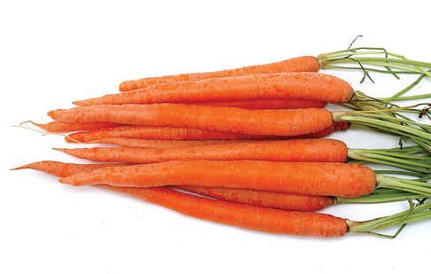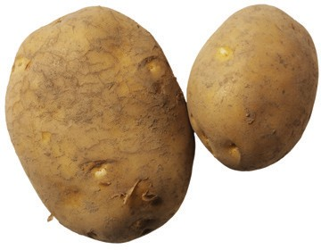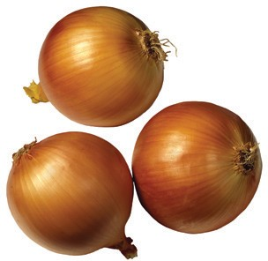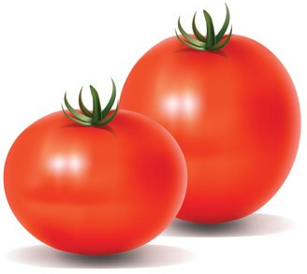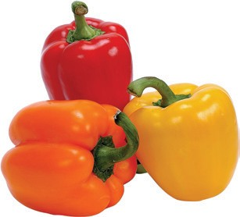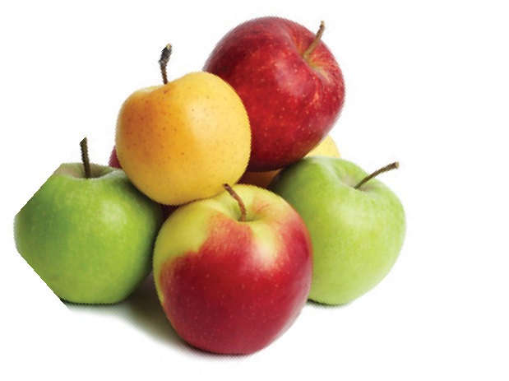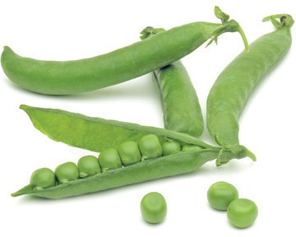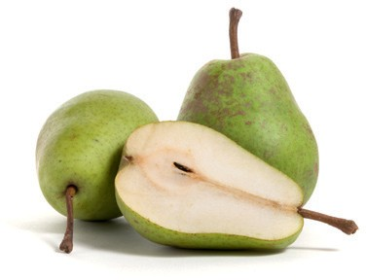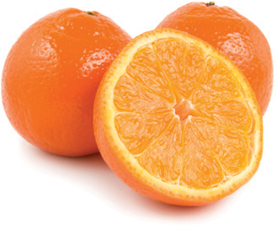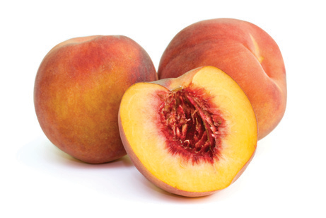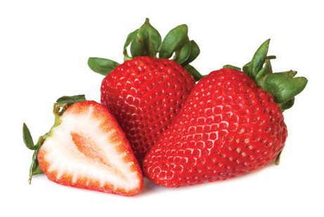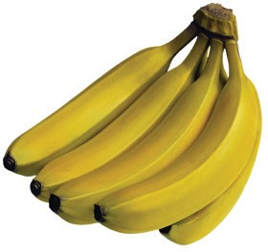

### Look!

#### one potato – two potato**es** one tomato – two tomato**es** one peach – two peach**es**

one strawberry – two strawberr**ies**

I like apples.

I don’t like bananas.

I like apples **and** oranges.

I like apples, oranges **and** pears.

**Write some sentences about what you like and don’t like. Choose other words from the *Longman Photo Dictionary* if you want.**

....................................................................................................................

....................................................................................................................

....................................................................................................................

....................................................................................................................

# At the supermarket

**Ask your partner:** How often do you go to the supermarket?

What do you buy every week?

## Look at the pictures. What do you buy? Tell your partner.

**1 2**

**6 7**

**11 12**

**3 4 5**

**8 9 10**

**13 14 15**

bread wine milk chicken beer pasta eggs tea butter fish

fruit juice coffee cheese rice

meat

**Check in the *Longman Photo Dictionary*. Write the words.**

**1** .....................................................

**2** .....................................................

**3** .....................................................

**4** .....................................................

**5** .....................................................

**6** .....................................................

**7** .....................................................

**8** .....................................................

**9** .....................................................

**10** .....................................................

**11** .....................................................

**12** .....................................................

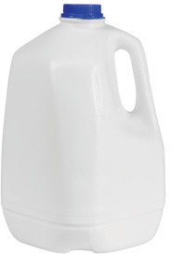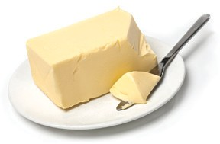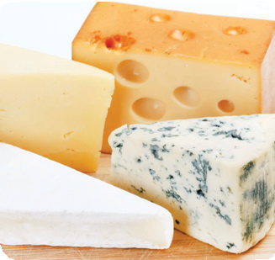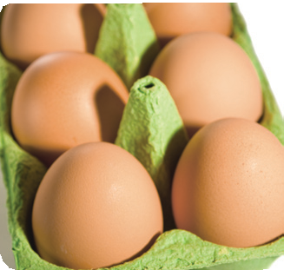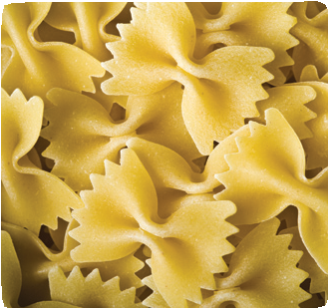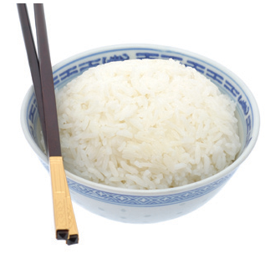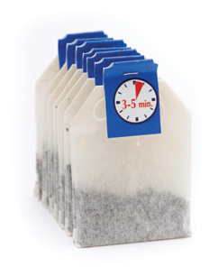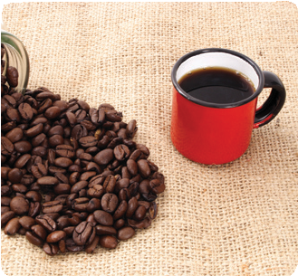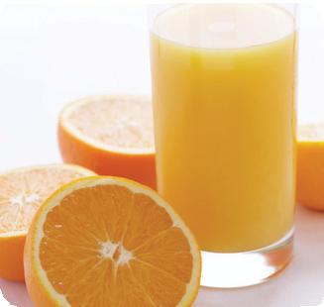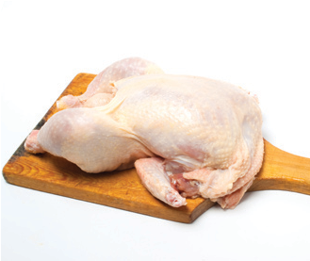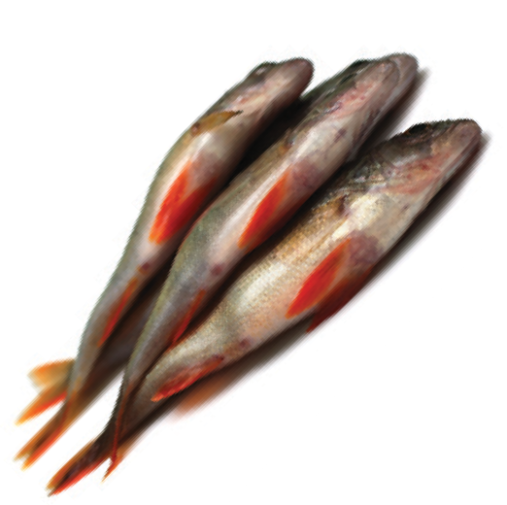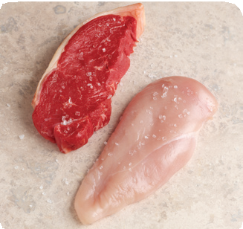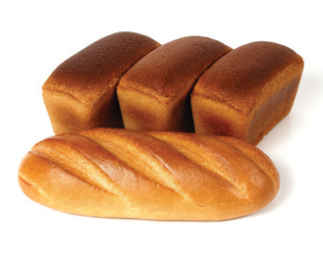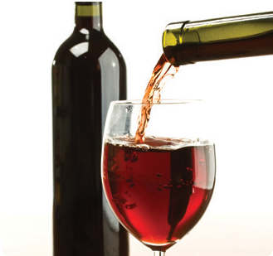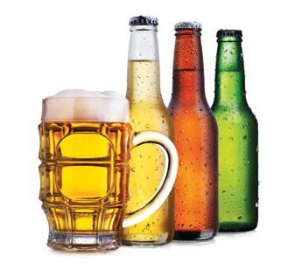

**Look!**

I buy milk **every week**.

I **usually** buy tea. I **sometimes** buy coffee.

I **never** buy beer.

## Now write some sentences about what you buy and don’t buy.

....................................................................................................................................................

....................................................................................................................................................

....................................................................................................................................................

....................................................................................................................................................

....................................................................................................................................................

# Healthy eating

## Which foods do you like? Tell your partner.

**Which foods are healthy? Write the words in two lists.**

### Healthy Not healthy

carrots tomatoes hamburgers sausages oranges chips chocolate apples orange juice cakes

**Look!**

Oranges are healthy. Chips are not healthy. Oranges are good for you. Chips are bad for you.

**Read the sentences. Tick (**✓**) or cross (**✗**) for you.**

**Then ask your partner. Tick (**✓**) or cross (**✗**) for your partner.**

**Is it healthy? Tick (**✓**) or cross (**✗**).**

**Your**

**You partner**

**Is it healthy?**

#### I eat fruit and vegetables five times a day.   

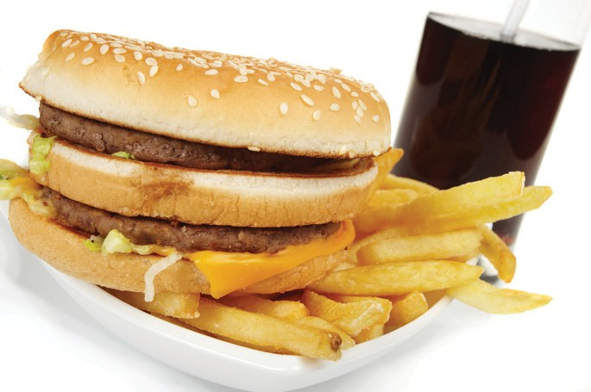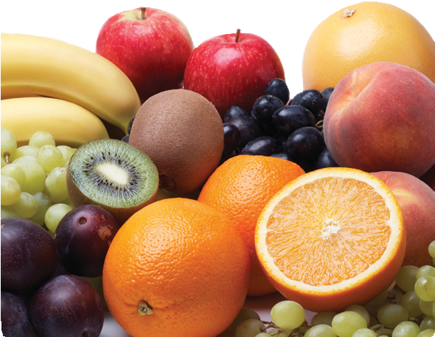

1. I drink coffee five times a day.   
2. I eat a lot of potatoes, rice and pasta.   
3. I eat cakes and chocolate every day.   
4. I eat chips every day.   
5. I drink one litre of water or fruit juice every day.   
6. I eat a lot of bread.   
7. I put a lot of butter on my bread.   
8. I eat sausages and hamburgers every day.   
9. I drink a lot of cola.   
10. I drink a lot of alcohol.   

**Now read the text. Check your answers. Were you right?**

**HEALTHY EATING**

#### Eat a lot of fruit and vegetables. Eat five portions a day.

* + Potatoes, rice and pasta are good for you. You can eat a lot of them.
  + You can eat a lot of bread, but don’t put a lot of butter on your bread.
  + Drink a lot. You can drink water or fruit juice, but don’t drink a lot of coffee.
  + Don’t drink cola. It has a lot of sugar.
  + You can drink a little alcohol but not a lot.
  + Don’t eat chips, sausages and hamburgers. They make you fat.
  + Don’t eat a lot of cakes and chocolate. They have a lot of sugar and they make you fat.