**UNIT 8: Light**

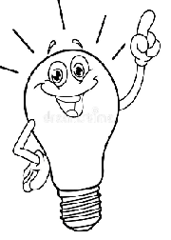

1. **Fill in blanks**
2. All light on the Earth comes from ……….
3. When something gives out light by itself, it is called a ………
4. Things which cannot give out light by itself is called a………
5. Things that let light pass through them called ……………….
6. Things we cannot see through at all called……………………
7. **Write Yes or No**
8. There is less light away from the source **…………**
9. AStar, a fire are luminous things…………………..
10. The Sun is a non-luminous body…………………….
11. Glass air and water are transparent…………………..
12. A beam of light travels in a straight line……………..
13. Shadows are made by sunlight……………………….