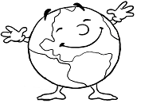**UNIT 9: The Earth**

1. **Draw and Color the Earth**.

|  |
| --- |
|  |

1. **Write Yes or No.**
2. The sun rises in the east___________________________
3. The Earth is a star____________________
4. The earth side that faces the sun has night____________________
5. The Sun rises in the evening ____________________
6. **Fill in the blanks with the correct answer.**
7. The earth goes around the _____________________.
8. The sun is a ________________________.
9. The earth gets light from the ____________________.
10. The Earth has ______________, __________________, and air.