# Unit 1

# 1.-Read the definition of life processes and match.

* Living things make new living things. interaction
* Living things interact with each other

and with their environment. nutrition

* Living things need food. reproduction

# 2.- Read and write animals or plants.

a. They move from place to place. .......................................

b. They can communicate. ............................................

c. Their roots hold them in the ground. ......................................

d. They are born from eggs or from their mother´s womb .............................

e. They can make their own food using water, sunlight, air or soil.

.....................................

f. They produce seeds. .................................

**g.** They cannot move from place to place. ......................................

# 3.- Look and match the animals to their habits.

desert forest pond rainforest The Arctic savannah

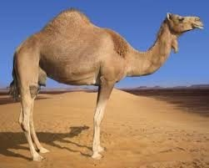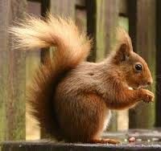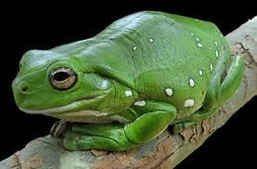

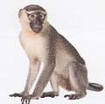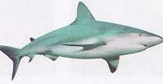**4.- Read and write carnivores, herbivores or omnivores.**

1. Bears eat plants, fish, small animals and insects. They are ….....................
2. Rabbits eat grass and leaves. They are …...............................

c. Lions eat other animals. They are …...................................

**d.** Human beings eat meat, fish, fruit and vegetables. We are …..................

# 5.- How are animals born? Read and match.

1. Viviparous animals are born oviparous.
2. Oviparous animals are born from eggs.
3. Elephants are warm by sitting on them.
4. Frogs are viviparous.
5. Baby viviparous animals from their mother´s womb.
6. Birds keep eggs drink their mother´s milk.

# 6.- Find and circle five animals.

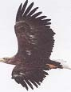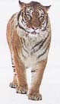

**Now complete the sentences**

**a.** An ........................................... can fly.

b. A ........................................ can walk.

c. A ...................................... can climb.

d. A ...................................... can slither.

**e.** A ...................................... can swim.

# 7.- Complete your bilingual dictionary.

|  |  |  |
| --- | --- | --- |
| **LIVING THINGS** | | |
| * Living things: * Non-living things:   - Interaction:   * Nutrition:   -Reproduction:   * Moving: | * Natural: * Man-made: * Habitat: * Adapt: - Carnivore: * Herbivore: * Omnivore: | * Oviparous: * Viviparous: * Mother´s womb: * Mother´s milk: * Hatch: |