|  |  |
| --- | --- |
| Name: |  |

1. ***Look outside and circle the words that tell about the weather today.***

*The sky is: (sunny - cloudy) It is (rainy - snowy -****dry****)*

*It feels (cold - cool - hot - warm)*

*It is (windy - calm)*

# *Identify each type of weather.*

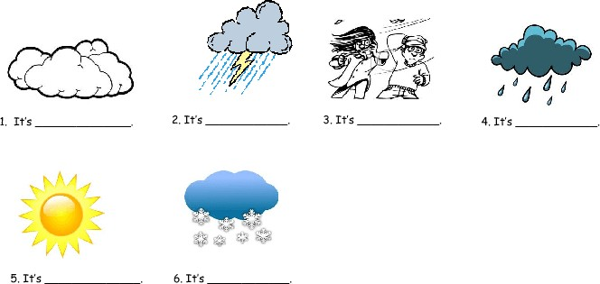

*Word bank Stormy Windy Sunny Snowy Cloudy*

*Rainy*