**Student Name: ___________________ Date: / /   
  
Unit: 6 fruits and seed   
1. Write the name of each fruit under each picture and circle the fruits which have seeds.**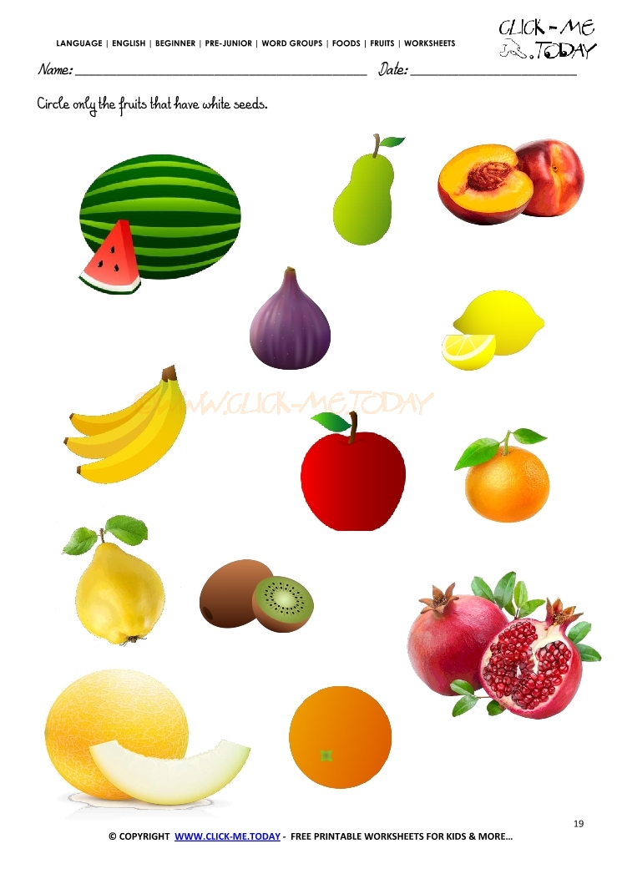  
2. Color the seed and mention all its parts

2. 