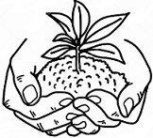**UNIT 10: SOIL**

1. **Fill in blanks**
2. Some soils are good, many plants grow in them, such soils are called _______________
3. Remains of dead plants and animals in the soil are called______________
4. A soil which has humus is of a dark _______________ color.
5. What are the different kinds of soil _______________ , _______________, and_______________
6. The best kind of soil for plants_______________
7. **Read the statements below. Decide whether they are true or false.**

|  |  |  |
| --- | --- | --- |
| Statements | True | False |
| 1. Clay holds water more than sand. |  |  |
| 1. Sand holds air more than clay. |  |  |
| 1. Soil can be easily washed away by water or blown away by wind. |  |  |
| 1. Humus helps the soil to hold air and water. |  |  |