**UNIT 5: Leaves**

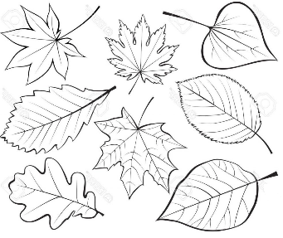

1. **Fill in blanks**
2. The flat, green part of the plant is……..
3. The green color of leaf is due to a colored substance called ….
4. Green leaves make …………for the plant.
5. The Food of plant is………
6. A leaf makes food with the help of ……., and………
7. The small leaves of a compound are called ………….
8. **Draw a leaf with mid-rib and veins in it**.

|  |
| --- |
|  |