**Unit 2: kinds of Animals**

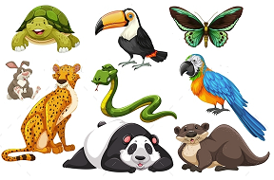

1. **Match animals to the coats**.

|  |  |
| --- | --- |
| **A** | **B** |
| Fish  Porcupine  Parrot  Rabbit | Quills  Feathers  Fur  Scales |

1. **Fill in the table about where animals live.**

|  |  |  |  |  |
| --- | --- | --- | --- | --- |
| Animal | Very cold place | Very hot place | Water | Land and water |
| Crocodile |  |  |  |  |
| Starfish |  |  |  |  |
| Octopus |  |  |  |  |
| Penguin |  |  |  |  |
| Camel |  |  |  |  |
| Polar bear |  |  |  |  |
| Tortoise |  |  |  |  |

1. **Color the picture.**

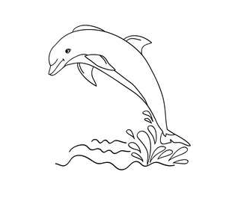

1. **Fill in blanks**
2. Ostrich lives in very hot places……
3. Ladybird lives in water…………….
4. Crocodile looks like a star …………
5. A jellyfish has a shell………………..
6. An octopus has six legs **…………….**