**Unit 10: Sound**

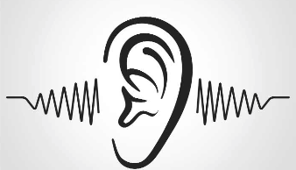

1. **Read the statements. Decide if they are true or false**

|  |  |  |
| --- | --- | --- |
| Statements | True | False |
| 1. Air makes our eardrums vibrate, we hear sounds**.** |  |  |
| 1. Vibration are passed from molecule to molecule we call this a sound wave, |  |  |
| 1. Sound can travel through space. |  |  |
| 1. If we like a sound we call it noise, |  |  |
| 1. Echoes can be used to detect shoals of fish and submarines. |  |  |
| 1. Bats make high squeaking sounds and use their ears to pick echoes from objects around them. |  |  |

1. **Using your own words, explain how people hear the sounds around them**?