**Everyday Science Grade (3)**

**Summary:**

**Unit One: (living Things)**

1. Earth is the only planet which has water and oxygen.
2. Oxygen helps to burn the food inside our bodies to give us energy.
3. The taking in of oxygen inside the body is called **breathing**.
4. Animals living on the land breathe by taking air into their **lungs**.
5. All living thing need water, and food.
6. Animals cannot make their food and eat plants are called **herbivores**.
7. Animals that eat the meat of other animals are called **carnivores**.
8. Human beings and some animals eat both plants and animals, they are called **Omnivores**.

**Unit Two: (Types of living Things: Animals)**

1. All animals can be put into one group –**the animal group**.
2. All plants can be put into **plant group**.
3. Animals can be further put into smaller groups called **classes**.
4. There are five classes of animals that have **back bones**. **Amphibians,**

1. There are animals without backbones; they can be divided into classes: animals with spiny skins, animals with shells, worms and animals with jointed legs like insects.
2. **Fish** live in water, covered with scales on their skin.
3. **Amphibians** are animals that spend part of its life in water and part of its life on land.
4. **Reptiles** live on land; they have dry, scaly skins. They breathe air through their **lungs**.
5. **Birds** live on land; their bodies are covered with feathers. Birds have **sharp beaks and claws.**
6. Most mammals live on land; their skin is covered with hair or fur.

**Unit Three: (Types of living Things: Plants)**

1. Green plants make their own food; they need air, **chlorophyl**l and water.

* **Structure of flower** :

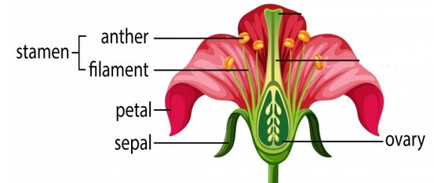

* **Petal**: - The colored part of a flower that attract insects.
* **Sepal**: - external covering of flower bud.
* **Stamen**: this part of plant makes pollen.
* **Ovary**: Inside the ovary is an ovule that, when fertilized, will develop into a seed.
* The lower part, or ovary, of the carpel grows big to make the **fruit**.
* Plants that have cones, they have two kinds of cones. There are pollen cones which have **pollen**, and there are **seed cones** which make **seeds.**

**Unit 4: Matter**

1. All thing are made of **Matter**, matter takes up space and has weight.
2. Matter can be solid, liquid or gas.
3. We learn about matter with our **senses**.
4. Matter is made of **molecules**; a molecule is the smallest part of something.
5. Matter can change its form.
6. After putting an ice cube nears a **sunny** window, we will see water, the ice has melted, and heat can change a solid into a liquid.
7. Heating water in a pan, you will see steam coming out; this gas is called **water vapor**.
8. Molecules in solid are closed together; a solid cannot change its shape easily.
9. Molecules in liquid move that is why a liquid can change its shape.
10. Molecules in a gas are very far away from each other, they can move freely in any directions.

**Unit (Five): Air**

* There is a huge layer of air all around the earth.
* The atmosphere is made up of many gases; it has nitrogen, oxygen, and carbon dioxide.
* The atmosphere is pressing on us all the time, this is called **Air Pressure**.
* Air moves all the time due to air pressure, moving air is called wind.
* We can measure changes in pressure by an instrument called a barometer.
* A wind-vane tells us the direction of the wind.

**Unit Six: (Water):**

1. Water can change from one form to another by heating or cooling.

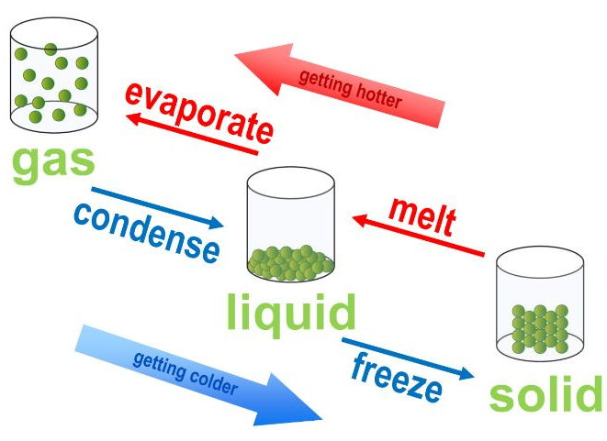

1. We can use water in many ways, like drinking, bathing, washing and boating.

**Unit Seven (Force):**

* Pushes and pulls are called **forces**.
* Kinds of energy: **solar** energy, **heat**, **electrica**l and **light**.
* The Earth is round but things do not move away from the earth, the force of gravity pulls everything towards it.
* **Friction** is the resistance of motion when one object rubs against another. Anytime two objects rub against each other, they cause friction. Friction works against the motion and acts in the opposite direction.

**Unit Eight (Heat):**

* Fire gives us **heat** and light; heat is a kind of energy.
* Heat energy comes from **sun** and burning wood, paper and other flues.
* To find out how hot something is we use an instrument called **Thermometer**.

**Unit Nine: (light):**

1. Reflection is when light bounces off an object. If the surface is smooth and shiny, like glass, water or polished metal, the light will reflect at the same angle as it hit the surface**.**

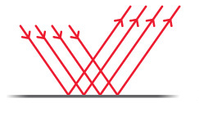

1. Light travels very fast, and in **straight lines.**
2. **Rainbow** is a big band of seven colors; we can seeit in the sky after rain**.**
3. Animals and plants need light and heat.

**Unit 10: Soil**

1. Land is covered with soil.
2. Plants grow in fertile soils.
3. Remain of dead plants and animals in the soil are called **humus.**

**Unit 11: The Sun and Planets**

1. **Stars** are big balls of burning gases; hey give out heat and light.
2. **Planets** are bodies that move around the sun, the sun has nine planets moving around it. The sun and the nine planets are called the **solar system**.

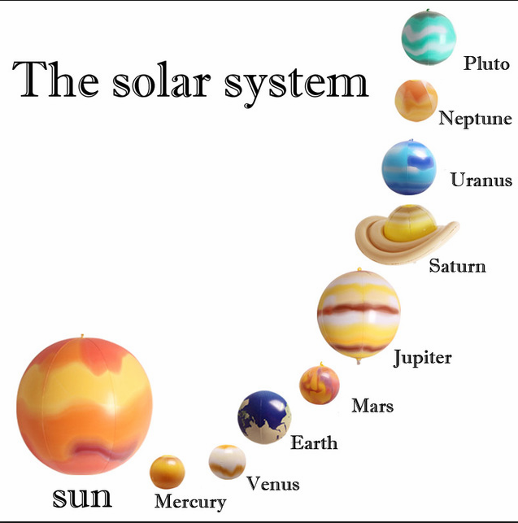

1. Machines that travel in space are called **Spaceship.**
2. People who travel in spaceship are called **Astronauts**.
3. The path of a planet around the sun is called **Orbit**.