**UNIT 6: Energy**

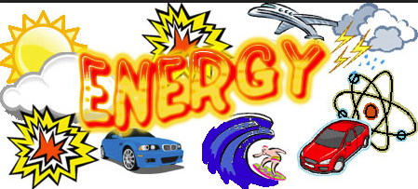

1. **Read the sentences below. Decide if they are true or false.**

|  |  |  |
| --- | --- | --- |
| **Statement** | **True** | **False** |
| Animals store energy in their bodies as fats. |  |  |
| A tank of oil is store of energy that can be burned to produce heat, this kind of stored energy is called electrical energy. |  |  |
| All forms of transport need energy to move. |  |  |
| Solids expand when they are heated. |  |  |

1. **What are the different forms of energy? Mention one example.**

|  |  |
| --- | --- |
| Forms of Energy | Example |
|  |  |
|  |  |
|  |  |
|  |  |
|  |  |
|  |  |
|  |  |