First Semester
Final Exam

Student’s Name:______________________________
Grade Two
Section: _______________
Teacher’s Name: __________________________
Final Mark: _______ / ______

Question One: This is your passport fill in the information required:

Name : _____________________________________
Nationality : _________________________________
Country : ___________________________________
City: _______________________________________
My country is ruled by : ________________________________
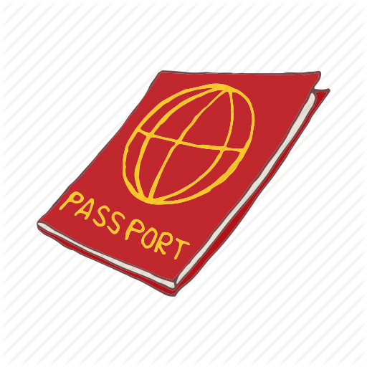

Question two: Decide if the following Sentences are True or False:
1.I can leave my country without a passport. ( )

2.In any community people have writes and should do some responsibilities. ( )

3.There are nine continents in the world. ( )

4.Sudan is an African Arab country. ( )

Question three: What does each of the following road sign indicate?
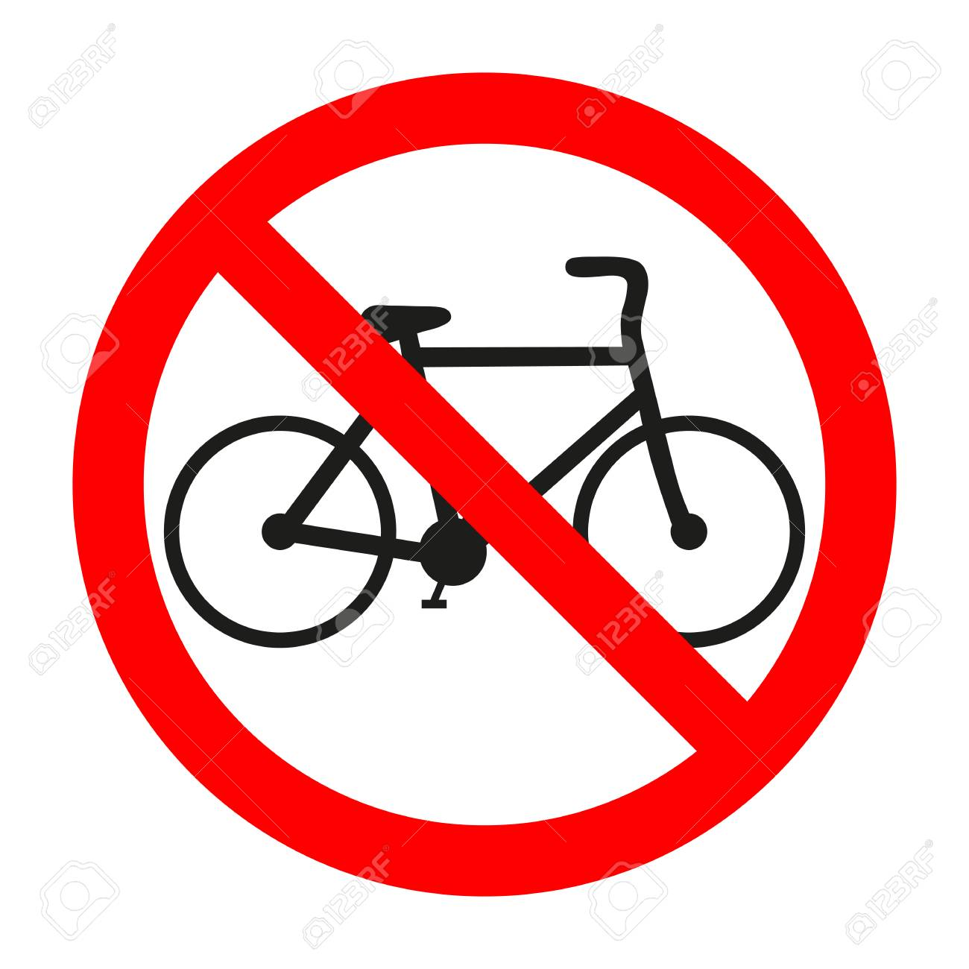
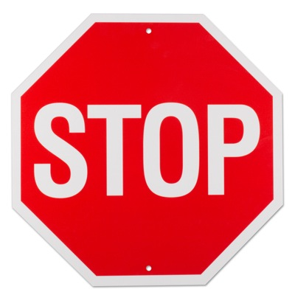
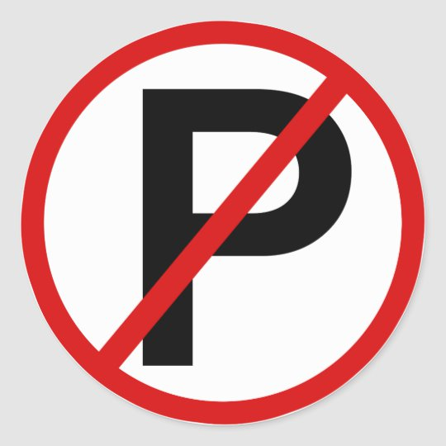

Question Four: Color the following traffic light then write down what each color means:

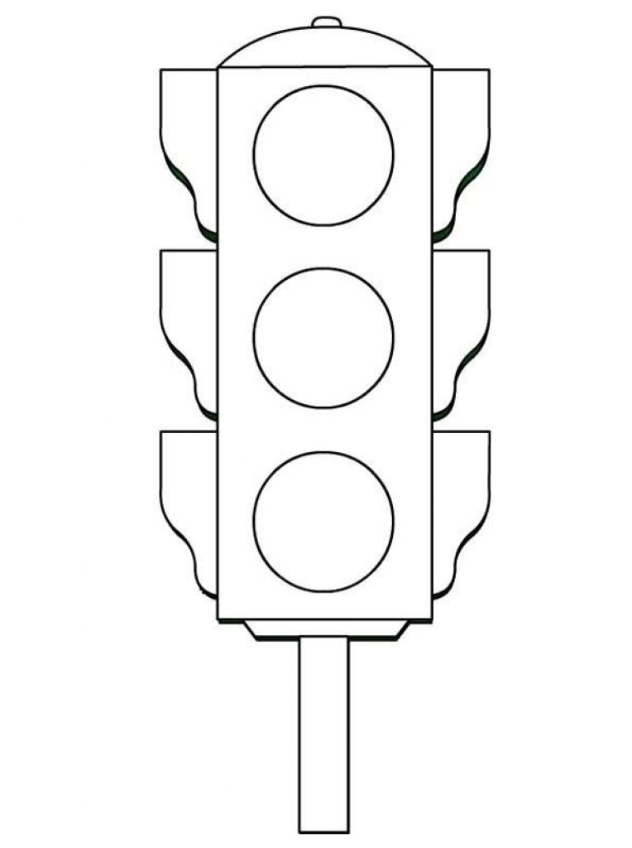

Question five: Complete the names of the following sentences with the right word:


1. ___________________ make the country a safe place to live in .

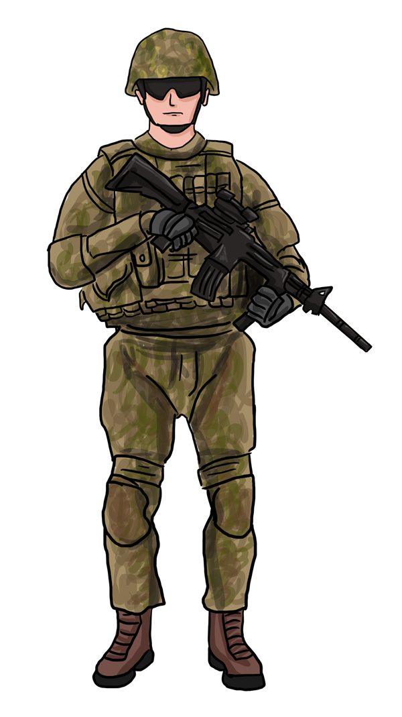

2. A _________________ protects his country from enemies.

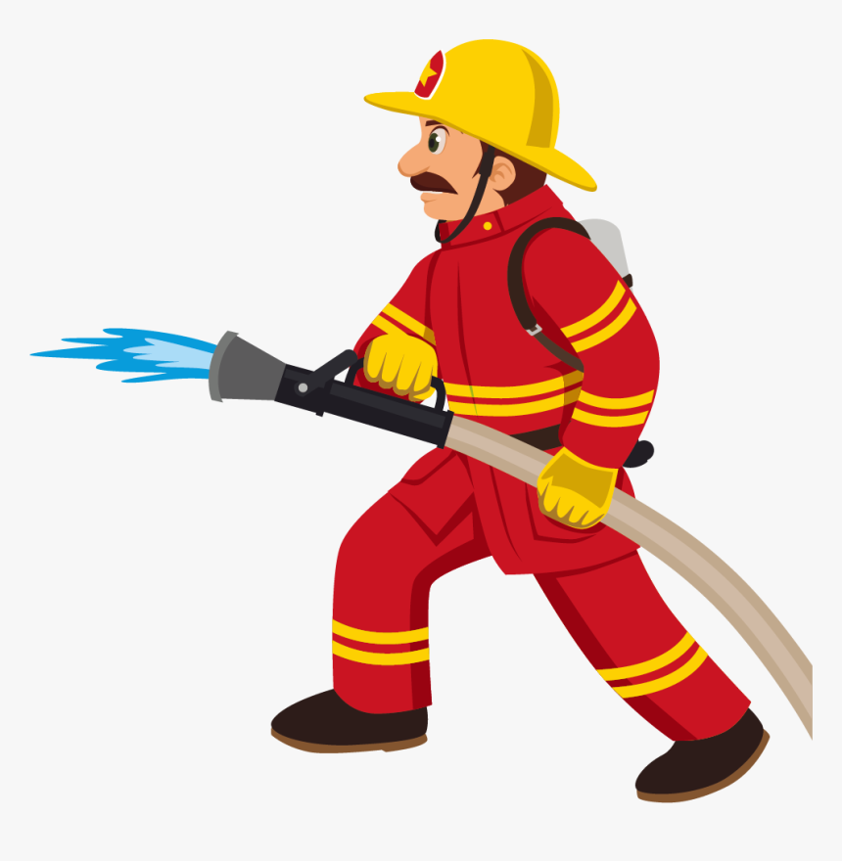

3. A ___________________rescue people inside buildings that are on fire.

Question six: Choose one of the jobs in the box to complete the sentences with the suitable kind of service:
Construction workers Doctors trash collectors postmen

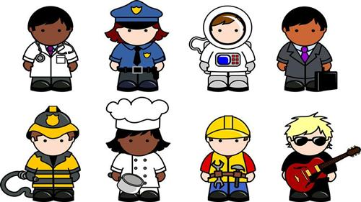

____________treat patients.
In Jordan there are many ___________________ that keep the streets clean.

.
__________________________ build many kinds of buildings such as houses and factories.
_________________ deliver letters.

Question seven: Write under each of the following models what each model it is of:


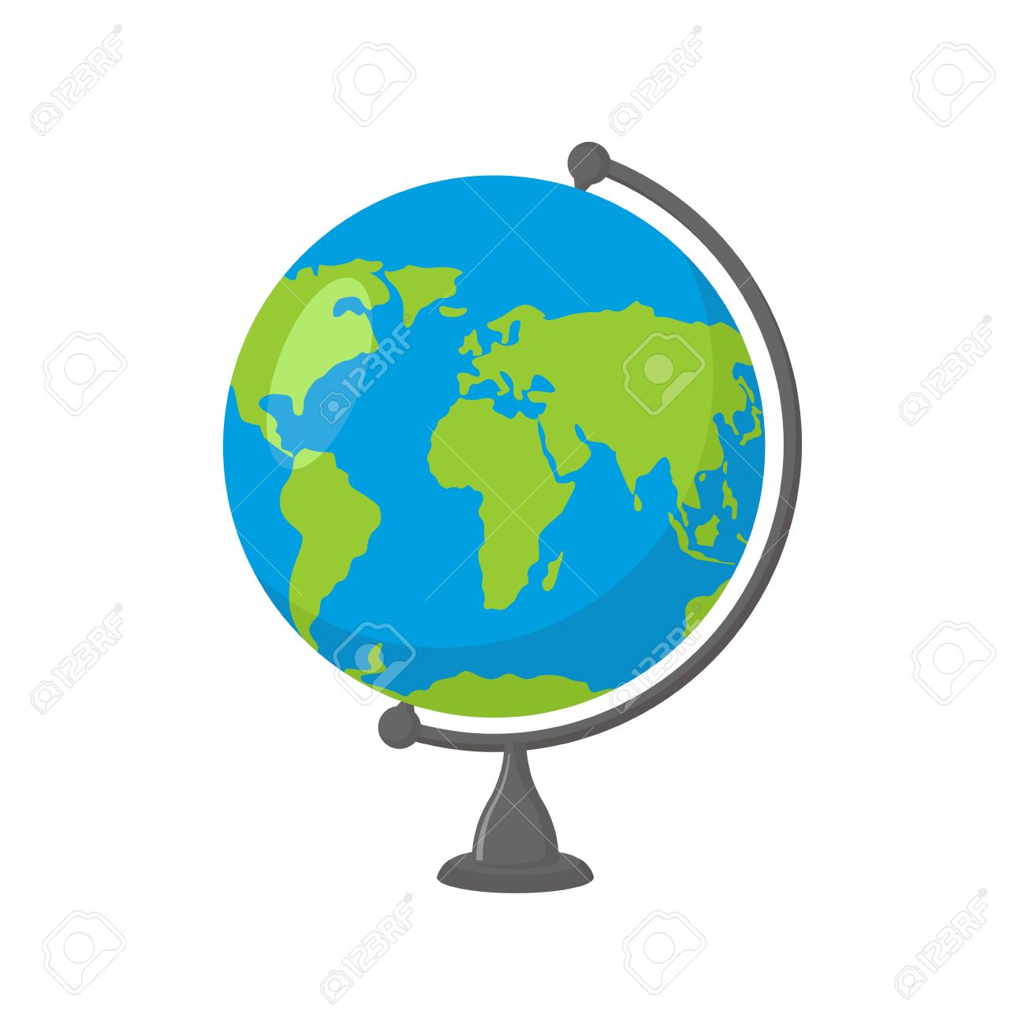

Question eight : Choose the correct answer:



- The one who lives in a community is called ( citizen/ person)

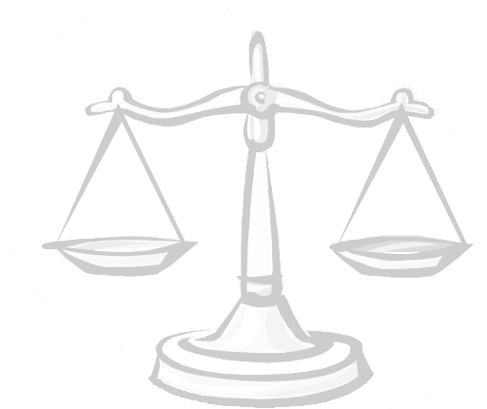

2. The law makers in any community are called (government/ police)

Question nine: Order the continents in the box from the largest to the smallest:

- _________________________
- Australia
- Africa
- North America
- Asia
- South America
- Antarctica
- Europe
- _________________________
- _________________________
- _________________________
- _________________________
- _________________________
- _________________________

Question ten : Locate the continents in the previous question on the map:

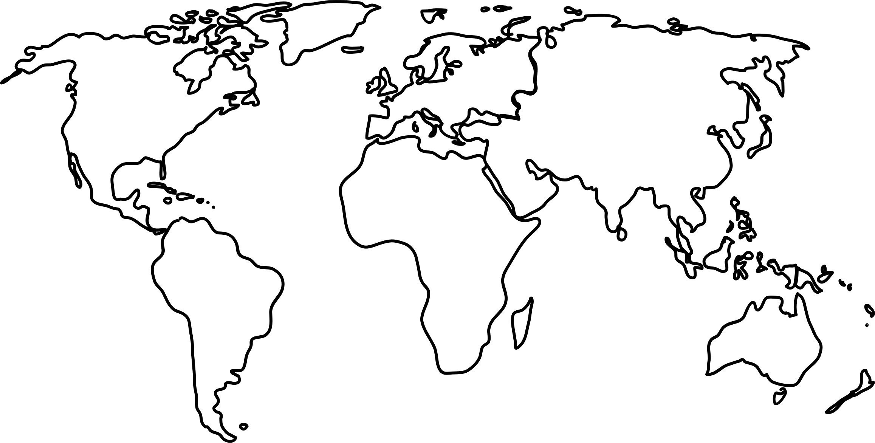

1
4
6
2
5
Question eleven: Write in the box opposite to each flag the name of the Arab country it belongs to:
7
3

