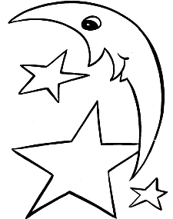**UNIT 8: The Moon**

1. Write the name of the moon’s shape below.

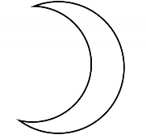

_________________________

1. **Choose the right answer :**
2. We can see the Moon__________.
3. at day time b. at night
4. The moon is____________ .
5. close to earth b. very far away from earth
6. The Moon_________.
7. gives us heat b. does not give us heat
8. The Moon__________.
9. has air b. does not have water

1. **Draw a half Moon.**