NAME:

# Make Models of Atoms of Elements

Make models of several of the smaller atoms. Use whatever you can find easily for the electrons, neutrons, and protons. You can use peas, plastic foam balls, old golf balls, fruit, or whatever you can get easily. You could even make models that could be eaten for lunch!

Make the neutrons and protons about the same size and different colors. Glue or fasten them together to form the nucleus. Use something smaller for the electrons.

The easiest way would be to fasten the parts to a piece of cardboard. If you can hang them in the air, that could look be even better. Try hanging the nucleus and electrons from strings inside a cardboard box.



Collect samples of elements

## Make a collection of as many pure elements as you can find. Compounds containing the elements don’t count. Some of the easiest to get are listed below in order of atomic number.

|  |  |  |
| --- | --- | --- |
| **Atomic Number** | **Element** | **Example** |
| He C  Mg Al Cr Fe Ni Cu Zn Ag I  W  Pt Au Hg Pb | Helium Carbon Magnesium Aluminum Chromium Iron  Nickel Copper Zinc Silver Iodine Tungsten Platinum Gold Mercury Lead | in a helium balloon  as a lump of coal or charcoal  scraped from a galvanized nail  from a light bulb |

You might also be able to find silicon (Si), sulfur (S), and calcium (Ca)

# Molecular Models



We have studied atomic models, but we have not studied molecular models. Most kinds of molecular models show the bonds and the atoms but not the electrons, neutrons, and protons.

Look for some pictures of molecular models, and think about how you would make them with things you can find. Your school may also have kit for making molecular models. The most common kind of molecular model is the stick and ball model. The balls are atoms and the sticks are bonds. This is a stick and ball model of a water molecule..

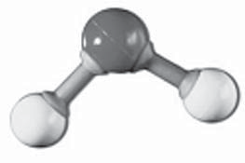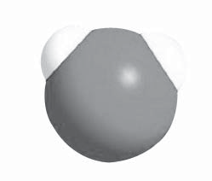

You will have to learn a little about chemical formulas and molecule shapes to make your models. Try to make some simple molecules, like oxygen, methane, ammonia, and methanol. Some things you

might try for model parts are tooth- picks for bonds and marshmallows, grapes, or plastic foam balls for atoms.

The small balls are hydrogen atoms, and the large ball is an oxygen atom. The sticks are bonds. Notice the balls are different sizes. Try to find a list of atom sizes so you know what size balls to use. Molecular models show the siz- es and shapes of molecules, but they don’t look exactly like molecules. The model below looks more like a real molecule.